Your Company Name
OPERATIONAL MANUAL

Issued Date |  | Issued By
Date Checked |  | Checked by
Released Date |  | Released by
Approval Date |  | Approved by

Document Reference: Operations Manual for Operational Authorisation
Issue: Ver 1.0 – 1 January 2022
Document Author: your name
Accountable Manager: company owner/director

Contents
List of Tables 5
List of Images 5
1.Introduction 7
1.1 Definitions 7
1.1.1 Definition of Terms 7
1.1.2 Abbreviations and Acronyms 8
1.2 System for Amendment and Revision of the OM 9
1.2.1 Amendment Table 9
1.2.2 List of Refence Documents 10
1.3 Record of Revisions with effective dates. 10
1.4 List of effective pages 10
1.5 Purpose and Scope of Operations Manual 10
1.6 Safety Statement 10
1.6.1 Safety Assurance 11
1.6.2 Safety Training 11
1.7 Approval of Signature 11
2.Description of the UAS Operator’s Organisation 11
2.1 Organisation overview - Organigram 11
2.2 Aeronautical Decision Making 12
2.3 Procedures & Checklists 12
2.4 Recurrent Training 13
2.5 Training of Staff involved in Operation. 13
2.6 Maintenance 13
2.7 Crew 13
3.Concept of Operations: 14
3.1 Nature of the operation and associated risks 14
3.1.1 Topographical Survey conducted with Multi-Rotor. 14
3.1.2 Bridge/Roof/Façade Inspections conducted with Multi-Rotor Drones. 14
3.1.3 Coastal Erosion/Defence/Flooding/Subsidence conducted with Multi-Rotor Drones 14
3.2 Operational environment and geographical area for the intended operations 14
3.3 Type of Operations 15
3.3.1 Duration of the Operations 16
3.3.2 Area of Operations 16
3.3.3 Typical Flight Missions uncontrolled Airspace 23
3.3.4 Level of Involvement (LoI) 29
3.3.5 Normal Operation Strategy 30
3.3.6 Standard Operating Procedures 32
3.4 SORA - Specific Operating Risk Assessment for Risk analysis and methods for reduction of identified risks 36
3.4.1 Applicability 36
3.4.1.2 Company RAMS (Risk assessments and Method Statements). 37
3.4.2 Ground Risk 37
3.4.3 Air Risk 46
3.4.4 SAIL 52
3.4.5 OSOs 53
3.5 Technical means used. 74
3.5.1 Multi-Rotor DJI Mavic 2 Enterprise Advanced 74
3.6 Competency, Duties and Responsibilities 75
3.6.1 Head of Drone Operations. 75
3.6.2 Safety Manager 76
3.6.3 Head of Training 76
3.6.4 Maintenance Manger 77
3.6.5 Remote Pilot/Chief 77
3.6.6 Remote Pilot 79
3.6.7 Visual Observer (VO - Optional) 80
3.6.8 Competency - Fitness for Duty 80
3.6.9 Competency - Shift & Working Hours 80
3.6.10 Competency - Medication & Wellbeing. 81
3.7 Training 81
3.8 Risk analysis and methods for reduction of identified risks 82
3.9 Maintenance 82
4. Normal procedures. 83
4.1 General procedures valid for all operations: 83
4.2 Procedures peculiar to a single operation 84
5. Contingency procedures 85
5.1 General procedures valid for all operations 85
5.1.1 Sudden Change in Weather into adverse conditions Actions. 85
5.1.2 UAS Departs the Flight Geography Actions 86
5.1.3 Sudden Mission Termination because of Compass Failure Actions. 86
5.1.4 Telemetry Loss during Flight Mission Actions 87
5.1.5 Interference Avoidance with Manned Aircraft Actions. 87
6. Emergency procedures 88
6.1 List of Possible Emergency’s 88
6.2 Fail Safe Procedure 88
6.3 Force Landing Procedure 89
6.4 Software Malfunction 90
6.5 Transmitter Failure/Frequency Interference 91
6.6 Loss of Propulsion/Motor or Propeller Failure 92
6.7 Aircraft Battery Failure 93
6.8 Loss of GPS Signal 94
6.9 Low Magnetic Field 95
6.10 Public Encroachment 96
6.11 Aircraft Incursion 97
6.12 Fly Away 98
6.13 Pilot Incapacitation 99
6.14 Fire Ground Equipment 100
6.15 Fire In Flight 101
7. Emergency response plan (ERP) 102
7.1 UAS Loss of Containment Emergency Actions 102
7.2 Immediately Post-Incident Actions 103
7.3 Environmental Emergency Actions 103
7.4 UAS Loss of Containment Emergency Actions. 104
8. Security 104
8.1 Operational 104
8.2 Data Protection 105
9. Guidelines to minimise nuisance and environmental impact referred to in UAS.SPEC.050(a)(v); 106
10. Occurrence reporting procedures according to Regulation (EU) No 376/2014. 107
10.1 Reporting 107
10.2 Starting a report. 107
10.3 Reporting Procedure. 108
11. Record-keeping procedures 110
11.1 Pilot Logbook 110
11.2 Flight Logbook 111
11.3 Battery Logbook 112
11.4 Drone Maintenance Logbook 113

List of Tables
Table 1: Abbreviation 9
Table 2: Amendment Record 10
Table 3:List of References 10
Table 4: Record of Revisions with effective dates 10
Table 5: Company Structure & Personnel 12
Table 6: Flight Mission parameters 23
Table 7: Controlled airspace parameters 23
Table 8: Emergency Phone Contacts 36
Table 9: Ground Risk Mitigation Robustness 39
Table 10: Summary of the OSO Analysis 56
Table 11: List of Pilots 75
Table 12: Pilot Logbook 110
Table 13:: Flight Logbook 111
Table 14:Battery Logbook 112
Table 15: Maintenance Logbook 113

List of Images
Image 1: Shannon FIR (Flight Information Region) 16
Image 2: Population Assemblies 17
Image 3: Ground Infrastructure by County 18
Image 4: Example of Rural Aerodrome 19
Image 5: LTE Connectivity Coverage for Vodafone 20
Image 6: LTE Connectivity Coverage for Three 20
Image 7: Temperature Average 21
Image 8: Daily Chance of Precipitation 21
Image 9: Average Wind Speed in Ireland 22
Image 10: Humidity Comfort Levels 22
Image 11: Hours of Daylight 22
Image 12:Typical Flight Mission 2D 24
Image 13:Typical Flight Mission 3D 24
Image 14:Typical Linear Mission 25
Image 15:Typical Waypoint Mission - Uncontrolled Airspace 25
Image 16: Typical 2D Mission - Controlled Airspace 26
Image 17:Typical Linear Mission - Controlled Airspace 26
Image 19:Typical 3D Mission - Controlled Airspace 27
Image 18:Typical Waypoint Mission - Controlled Airspace 27
Image 20: Containment/Geo-Fence/Boundary Box in DJI App 28
Image 21:Geo-Fence Parameters Diagram 28
Image 22:DJI Flysafe Geo-Zones 29
Image 23:Loss of Connection with DJI App Software 34
Image 24: Determination of Robustness Level SORA EU 2019/947 (Table 4) 36
Image 28:Air Risk Class Category 46
Image 29:Initial ARC Assignment (SORA EU 2019/947) 47
Image 30:Lowering the Initial ARC (SORA EU 2019/947) 48
Image 31:TMPR Integrity and Assurance Objectives (SORA EU 2019/947) 52
Image 27:Mavic 2 Enterprise Advanced 74
Image 28:Ground Risk / Air Risk Model 82
Image 29:Operational Volume 85

1.Introduction
Explain what this Manual is about and a very brief explanation of the type of Drone Operations and a brief outline of your company.

1.1 Definitions
The relevant definitions, terms and abbreviations used in this manual are described below:

1.1.1 Definition of Terms
Accident – An unplanned event or series of events that results in death, injury, or damage to, or loss of, equipment or property.

Cause – One or several mechanisms that trigger the hazard that may result in an accident or incident: the origin of a hazard.

Control – A current, planned, or proposed means to reduce or eliminate a hazard’s causes or effects.

Cruise – Defined as that phase of the flight that happens BVLOS, different than:
• Take-off & departure • Approaches & landing

Effect – The real or credible harmful outcome that has occurred or can be expected if the hazard occurs in a defined system state.

Hazard – Any real or potential condition that can cause injury, illness, or death to people; damage to or loss of a system, equipment, or property; or damage to the environment. A hazard is a prerequisite to an accident or incident.

Incident – An occurrence other than an accident that affects or could affect the safety of operations.

Likelihood – The estimated probability or frequency, in quantitative or qualitative terms, of a hazard’s effect or outcome.

Mitigation Measure (or Safety Requirement) – Action required to reduce the associated risk by lessening the severity of the resulting mishap or lowering the likelihood that a mishap will occur.

Risk (or Safety Risk) – The combination or composite of the predicted severity and likelihood of occurrence of a hazard’s effect or outcome. The expected value of loss resulting from the hazard.
Severity – The consequence or impact of a hazard’s effect or outcome in terms of degree of loss or harm to include death, injury, damage to or loss of equipment or property, damage to the environment, or monetary loss.

System State – An expression of the various conditions, characterized by quantities or qualities, in which a system can exist.

1.1.2 Abbreviations and Acronyms
Abbreviation / Acronym | Meaning
A/C | Aircraft
AGL | Above Ground Level
AED | Automatic External Defibrillator
AM | Accountable Manager
AMSL | Above Mean Sea Level
BVLOS | Beyond Visual Line of Sight
C2 | Command and Control Link
C3 | C2 + any communication required
CoG | Centre of Gravity
CONOPs | Concept of Operations
CPR | Cardiopulmonary Resuscitation
DAA | Detect and Avoid
DUTO | Declared Unmanned Aerial System training Organization.
EASA | European Aviation Safety Agency
EMC | Electromagnetic Compatibility
ESC | Electronic Speed Controller
ERP | Emergency Response Plan
FOM | Flight Operations Manager
GNC | Guidance Navigation and Control
GPS | Global Positioning System
HL | Heavy Lift
HOD | Hook On Device
IMU | Inertial measurement unit
LCD | Liquid Crystal Display
LED | Light Emitting Diode
L/H | Left-Hand
LTE | Long Term Evolution
MM | Maintenance Manager
MT | Maintenance Technician
NAA | National Aviation Authority
N/A | Not Applicable
N/C | Not Compliant
OM | Operations Manual
OSO | Operational Safety Objective
PIC | Pilot in Command
PPE | Personal Protective Equipment
R/C | Remote Control
RED | Radio Equipment Directive
RF | Radio Frequency
RFD | Radio Frequency Distribution
R/H | Right-Hand
RP | Remote Pilot
RTL | Return to Launch
SAIL | Specific Assurance and Integrity Level
SM | Safety Manager
SP | Safety Pilot
SRD | Short Range Device
TEM | Threat and Error Management
TMPR | Tactical Mitigation Performance Requirement
TRA | Temporary Restricted Area
UAS | Unmanned Aircraft System
UAV | Unmanned Aerial Vehicle
USB | Universal Serial Bus
VLOS | Visual Line of Sight
VMC | Visual Meteorological Conditions
VO | Visual Observer
VTOL | Vertical Take-off and Landing
Table 1: Abbreviation

1.2 System for Amendment and Revision of the OM
This Operations Manual is a living document for the guidance of all personnel involved in flight operations and as such is to be continuously reviewed and updated as necessary due to:

- Outcome of the study of incidents / accident reports

- Constructive submissions on the content of this manual as operational and technical content changes. All suggested amendments to this manual are to be submitted in writing to Your Company Name Flight Operations Manager completed with supportive evidence to help achieve the maximum safety and efficiency.

- Changes in regulations

1.2.1 Amendment Table
Amendment/Revision/Issue Number | Date | Amended By | Signed
Operations Manual: Version Number | Description of Change
Table 2: Amendment Record

1.2.2 List of Refence Documents
Number | Name of Document | Reference ID | Year | Revision
1
2
3
4
5
6
Table 3:List of References

1.3 Record of Revisions with effective dates.
Revision/Issue Number | Date | Amended By | Signed
Table 4: Record of Revisions with effective dates

1.4 List of effective pages
(List the Effective pages unless the entire manual is re-issued, and the manual has an effective date on it)

1.5 Purpose and Scope of Operations Manual
Write the main purpose of this document and give a brief description of the different parts of this document.
“The Your Company Name Operations Manual describes the organisation of our company, the concept of operations, the Normal Procedures, Contingency Procedures, Emergency Procedures, Emergency Response Plan, Security of the modification or interference of aircraft systems, personnel, flight operations and procedures by which the company conducts its business Unmanned Air System operations. The contents of this document do not override the requirement for continual review to ensure any new or amended regulation published from time to time by the relevant National Aviation Authorities addressed by this document.”

1.6 Safety Statement
To include a Statement to say that this OM complies with the relevant requirements of Regulation (EU) 2019/947 and with the operational authorisation received to Your Company Namefrom the Irish Aviation Authority (IAA).

“I hereby acknowledge that I have received the instructions, procedures and data contained in the OM complies with the relevant requirements of Regulation (EU) 2019/947 and with the authorisation or the terms of approval of the light UAS operator certificate (LUC), in the case of a LUC holder, and contains instructions that are to be complied with by the personnel involved in flight operations).”

1.6.1 Safety Assurance
In order to operate to the highest standards of safety, aircraft will be physically checked for defects before every flight and routine maintenance will take place on each aircraft after each flight or after the number of hours recommended by the aircraft manufacturer. Aircrew procedures from the start of operations to the end of operations will be followed implicitly and any incident will be recorded in the appropriate NAA documentation.

1.6.2 Safety Training
Safety training will take place every quarter within Your Company Name . It will involve reviewing procedures as well as looking at flight safety incidents that have occurred both internal and external to the company’s sphere of operations. Changes in the safety requirement will be recorded and disseminated to each staff member who will be prohibited from flying until the ‘changes document’ has been read and signed for.

1.7 Approval of Signature
The Your Company Name Operations Manual approval signature is to confirm that the contents of this document do not override the requirement for continual review to ensure any new or amended regulation published from time to time by the relevant National Aviation Authorities addressed by this document. The approval signature is also to confirm the Safety Statement above.

Signed
Date | January 2022
Accountable Manager
Your Company Name

For and on behalf of Your Company Name a company registered Company No:
Company address:

2.Description of the UAS Operator’s Organisation
Write a Brief Description of your company outlining your company strengths.
(a) The organisational structure and designated individuals. Description of the operator’s organisational structure, including an organisational chart showing the different departments, if any (e.g. flight/ground operations, operational safety, maintenance, training, etc.) and the head of each department;
(b) Duties and responsibilities of the management personnel,
(c) Duties and responsibilities of remote pilots and other members of the organisation involved in the operations (e.g. payload operator, ground assistant, maintenance technician, etc.).

2.1 Organisation overview - Organigram
Expand this if you need to.

Name of person | Role of Person | Contact – email & Phone |  | Remarks
Table 5: Company Structure & Personnel

2.2 Aeronautical Decision Making
Your Company Name UAS Remote Pilots are taught about the characteristics of analytical and naturalistic aeronautical decision making in the different phases of the operation.
In the internal training the pilots are provided with information and techniques to improve their aeronautical decision-making capabilities and make right decisions during the flight-preparations, abnormal and emergency situations.

2.3 Procedures & Checklists
Procedures and Checklist have been developed and improved through more than 2000hours of VLOS experience. Their improvement is continuous, and it is performed based on the study of the performance of the team and of occurrences related to the operation.

Withing the standard operational procedures the working and resting hours of the pilots are defined, as well as an evaluation of the pilot fitness using the acronym IMSAFE.
- Illness
- Medication
- Stress
- Alcohol
- Fatigue
- Emotions

2.4 Recurrent Training
After the investigation of occurrences new procedures may be developed. The UAS Remote Pilots are informed and trained on the new procedures and are encouraged to exercise this and the current ones safely during the operations. Your Company Name UAS Remote Pilots will conduct a training exercise once every 6 months at a minimum. During the exercises all ERP scenarios will be exhausted.

2.5 Training of Staff involved in Operation.
Your Company Name are not a Recognized Entity with the Irish Aviation Authority. All Drone Training and Licencing must be completed with a third-party company. This external company must be a Declared Unmanned Aerial System training Organization. (DUTO). Their experience and knowledge base must be in the field of VLOS/BVLOS Operations. This external company will conduct Training for VLOS operations covering STS-01 Operations and BVLOS operations Covering STS-02 operations. They will also have the ability to Conduct Flight Exams to certify UAS Remote Pilots. If a lesser Certificate is required, this external company will have the ability and knowledge to train and certify all Your Company Name Pilots.

2.6 Maintenance
The General Maintenance philosophy of Your Company Name is broken down into three factors.
- General maintenance
- Preventive maintenance
- Predictive maintenance

See Table 2 for the Your Company Name Maintenance Manual with reference to the Maintenance of the Aircraft.

2.7 Crew
As Stated in OM for reference of current document version see Table 2.

3.Concept of Operations:

3.1 Nature of the operation and associated risks
Below is a list of Drone Operations that we conduct within Your Company Name

3.1.1 Topographical Survey conducted with Multi-Rotor.
We conduct Topographical Surveys with the use of Multi-Rotor Drones for the purpose of capturing photos which enables Your Company Name to make 2D drawings for Clients. Quarries, Road Networks, Rail Networks, Waterways, The general hazards for Air and Ground Risk in which we encounter could be Birds, Poles, Live Trains passing at high speed, Live Cars Moving at high speed, wake turbulence is a possibility, vegetation, or livestock, moving water and walkers. For further risk and mitigation please see Section 3.4 SORA of this manual.

3.1.2 Bridge/Roof/Façade Inspections conducted with Multi-Rotor Drones.
We conduct Bridge/Roof/Façade inspections with the use of a Multi-Rotor Drone for the purpose of capturing photos to identify any possible defects that need to be address by the bridge/Roof/Façade owners. The general hazards for Air and Ground Risk in which we encounter could be Wi-Fi & Microwave antennas, Birds, Poles, Live Trains passing at high speed, Live Cars Moving at high speed, wake turbulence is a possibility, vegetation, or livestock, moving water and walkers. For further risk and mitigation please see Section 3.4 SORA of this manual.

3.1.3 Coastal Erosion/Defence/Flooding/Subsidence conducted with Multi-Rotor Drones
We conduct Coastal inspections with the use of a Multi-Rotor Drone for the purpose of capturing photos to identify any possible Erosion, Coastal Defence Issues or defects in the Defence products, any possible Subsidence of Sand Banks that may be a hazard to Buildings, People or Animals. Areas close to the coast like rail networks that could be potentially under threat of flooding. The general hazards for Air and Ground Risk in which we encounter could be Birds, Poles, Live Trains passing at high speed, Live Cars Moving at high speed, wake turbulence is a possibility, vegetation, or livestock, moving water and walkers. For further risk and mitigation please see Section 3.4 SORA of this manual.

3.2 Operational environment and geographical area for the intended operations
The Operational environment for drone operations in section 3 of this Manual, the Overflown area will be similar, Urban and Rural. Populated and sparsely populated areas in Urban and Rural areas.

Urban
The Topography of the area for Urban will be working within and around Cities, Towns, Villages, Harbours and Ports. Within Cities and Towns there would be built-up areas of buildings roads, rail, waterways, and park areas. The Ground Risk buffer will utilise the 1:1 rule when working in and around uninvolved persons. It is reasonable to consider that most of the non-involved persons will be located within a building.

Within the Urban Areas there could be a possibility of some type of electromagnetic environment, were Wi-Fi antennas and Microwave antenna may emit an electromagnetic signal that may interfere with the Drone Communications. The Emergency Immediate action for this is to fly out of the general area either in an upward motion or a backward motion. If this fails, the Drone has a safety feature when it loses communications with the remote controller it is designed by default to go into Return to Home function.

Rural
The Topography for Rural and sparsely populated areas Villages, small rows of houses along a country road. The Ground Risk buffer will utilise the 1:1 rule when working in and around uninvolved persons. The Air risk can increase for the possibility of unregistered Aerodromes. Remote Pilots will complete a Google Earth Pre-deployment reconnaissance on the Area to be flown for any unregistered Aerodromes within a 5km radius of Drone operational area. Most Rural Areas will be Uncontrolled Airspace this by nature reduces the Air risk from aircraft. But still does poses a different air risk as now all private aircraft will be conducting Visual Flight rules (VFR) flights. Depending on the type of Drone Operation an Aircraft Observer (AO) may be required.

Within Rural Areas you could be operating close to or around Wi-Fi and Microwave Antenna Sites. Some of these sites could emit an electromagnetic energy that could break communications between the Drone and the Remote Controller. The Emergency Immediate action for this is to fly out of the general area either in an upward motion or a backward motion. If this fails, the Drone has a safety feature when it loses communications with the remote controller it is designed by default to go into Return to Home function. When flying close to or within a 100meter radius of an electrical substation, the Pilot will at no time fly closer than 60meters to this obstacle. When flying close to or around an area that has high tension power cables the Pilot will not fly directly over these cables or with 30meters of them. These Cables can perform what is called an electrical Arc. If a drone is stuck by this arc it will result in the loss of operations.

3.3 Type of Operations
Your Company Name intends to carry out VLOS UAS operations.
- (A) Topographical Survey conducted with Multi-Rotor Drones.
- (B) Bridge/Roof/Façade Inspections conducted with Multi-Rotor Drones.
- (C) Coastal Erosion/Defence/Flooding/Subsidence conducted with Multi-Rotor Drones.
- (D) Electrical Substations/Phone Mast/Electrical Power cables with Multi-Rotor Drones.
Payload: RBG Camera

3.3.1 Duration of the Operations
The Duration of Operations will be as long as the Operational Authorization is valid for. In the case of modifications, the IAA will be contacted.

3.3.2 Area of Operations
The area of operations is defined by Shannon FIR, with a maximum altitude of 120m (400ft) AGL, see Figure 2.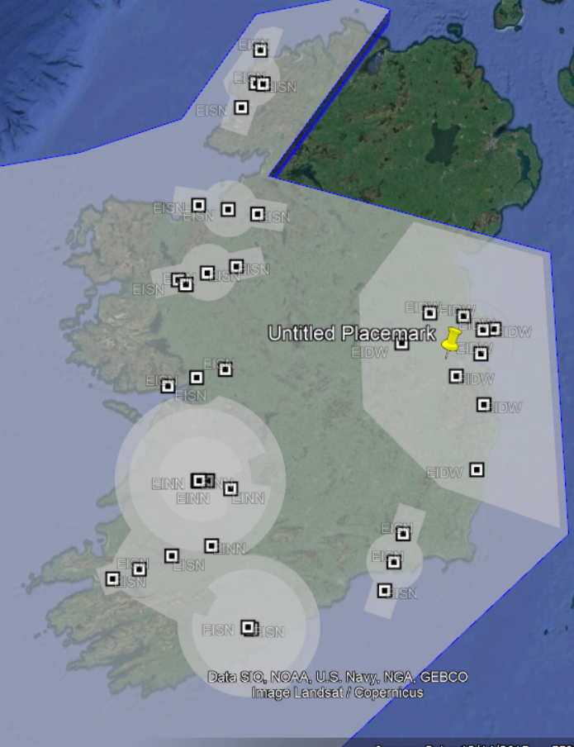
Image 1: Shannon FIR (Flight Information Region)

3.3.2.1 Ground Class
The volume of operations is defined above a sparsely populated environment & densely populated environment. Flight Planning and Flight mission will be planned in such a manner to avoid assemblies of houses or populated areas as much as possible. When flight planning it is more than likely there will be some Buildings/Roads/Railways are going to be affected by the emergency volume of the UAS and are therefore considered within the risk assessment, Section 3.

3.3.2.1.1 Population Assemblies
According to https://ec.europa.eu/regional_policy/mapapps/urban/degurba.html recommended by the EASA, there is either significant degree of industrialisation or urban clusters withing the area of operations, there is also a greater region of less industrialisation and Urban cluster than to Rural clusters. Figure 3.
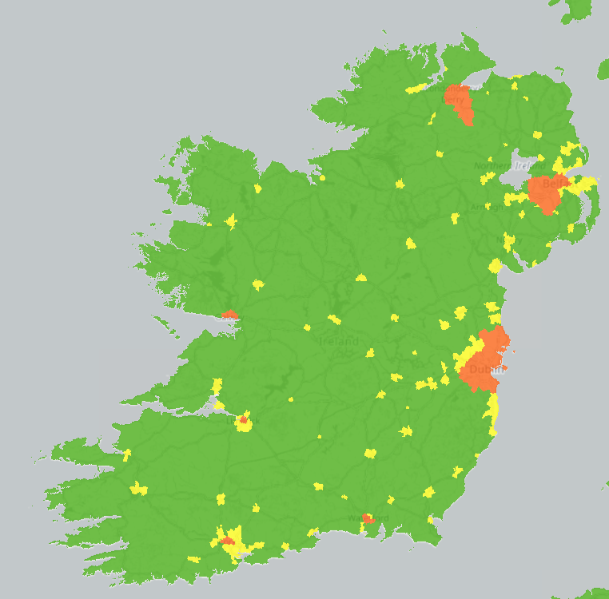
Image 2: Population Assemblies

3.3.2.1.2 Ground Infrastructure
The typical flight missions will involve flying over Road networks, Rail networks, Waterways, right of ways, foot tracks, buildings – Large, Medium and Small Powerlines, Bridges, planned routes/Missions will cross perpendicularly over the roads/rail’s networks and Waterways, all unnecessary areas will not be flown, and the most effective and efficient flight path will be chosen to cut down on the amount of time flown over any Infrastructure.
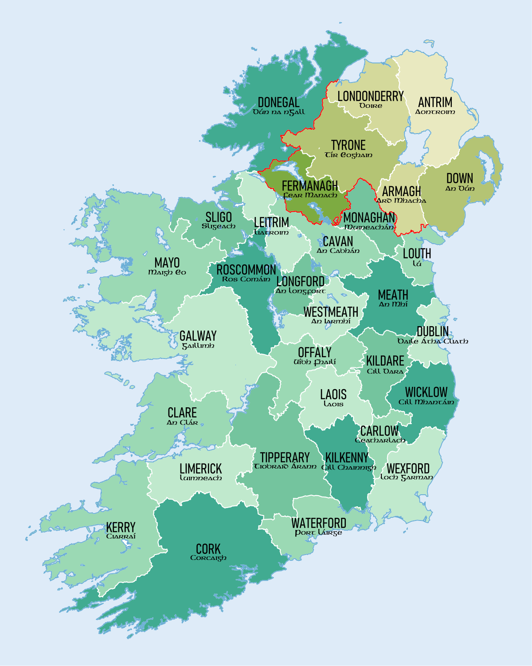
Image 3: Ground Infrastructure by County

3.3.2.2 Airspace Class
The airspace within the volume of operations could be any one of the following.
- Different Types of Airspace in Ireland.
- Class C – Controlled
- Class G – Uncontrolled
- Military Airspace
- Restricted
- Danger
- Military Operating Area
- Prohibited Airspace
- Air Traffic Zone (ATZ)
- Temporary Restricted Area
- Temporary Segregated Area

3.3.2.2.1 Airports, Airfields & Helipads
Your Company Name will be conducting Flight Operations in Rural and Urban within these areas there will be Registered and Unregistered Airfields/Airports/Helipads. We will cover all these in the SORA/PDRA. All RP will check the location for nearby Registered and Unregistered Airfields/Airports/Helipads, within a 5KM of the Survey site. They will make contact with the owner and inform them of our intended UAS operations. If the Owner does not respond, then the UAS Operation can still go ahead but the RP will try to make final contact prior to the Drone taking off.

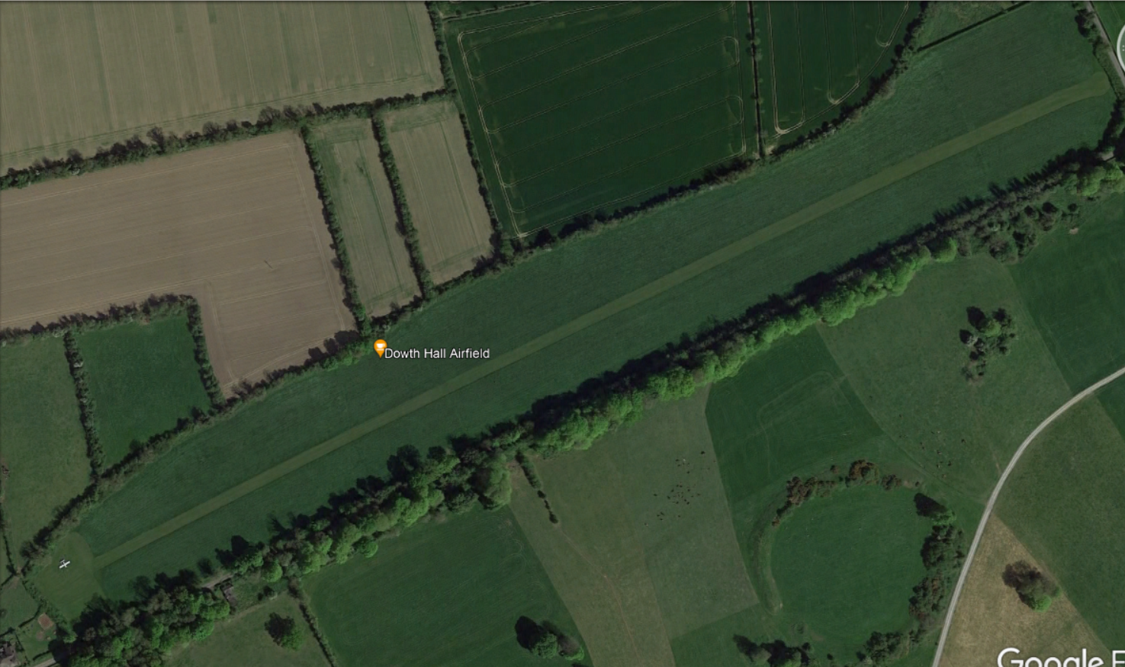
Image 4: Example of Rural Aerodrome

3.3.2.3 LTE Connectivity
Vodafone/Three are the chosen phone carrier. As shown in Figure 8, the 4G/LTE connectivity seems to be sufficient over the zones where the routes are planned. Nevertheless, the actual connectivity and reliability of the LTE network is to be tested during the scouting flights.
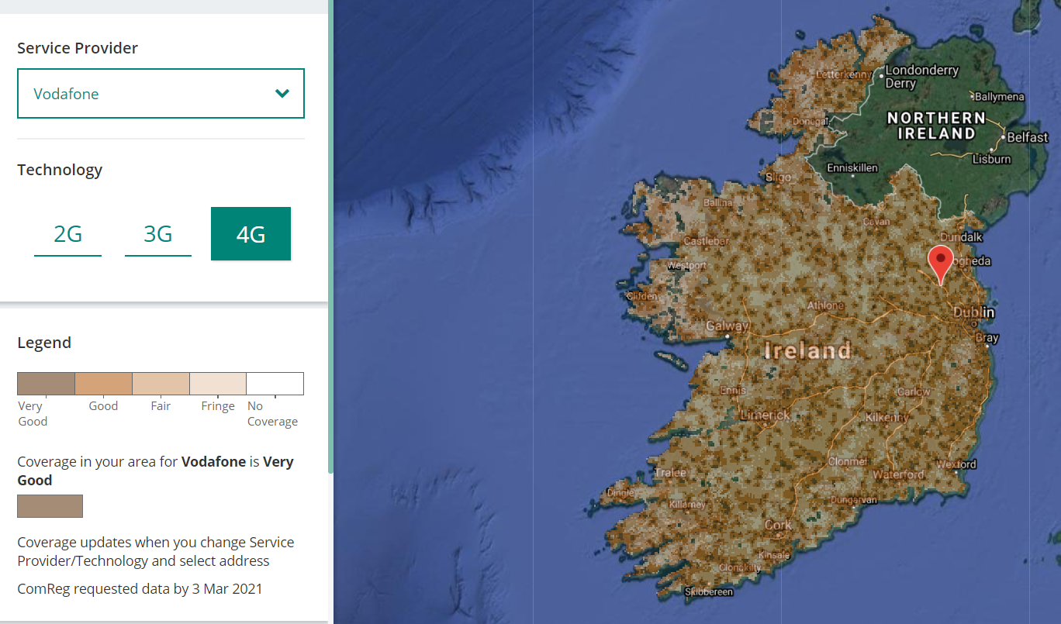
Image 5: LTE Connectivity Coverage for Vodafone

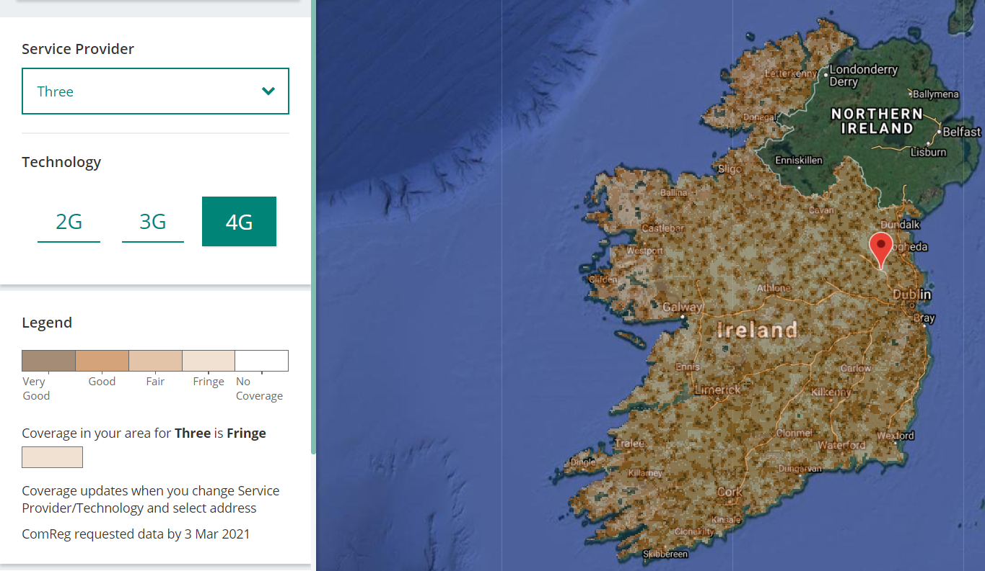
Image 6: LTE Connectivity Coverage for Three

3.3.2.4 Weather
The following information is extracted from https://weatherspark.com for the average weather throughout the year.
According to Figure 9 through Figure 12, the expected weather conditions for the time of operations is as follows:
- Temperature: the average expected temperature is 10-16°C.
- Rain: the average daily rain probability is significantly height, 33-40%.
- Wind: the average wind is significantly high (11-14 mph).
- Humidity: the humidity comfort level is comfortable.
- Daylight: there are at least 12h of daylight.
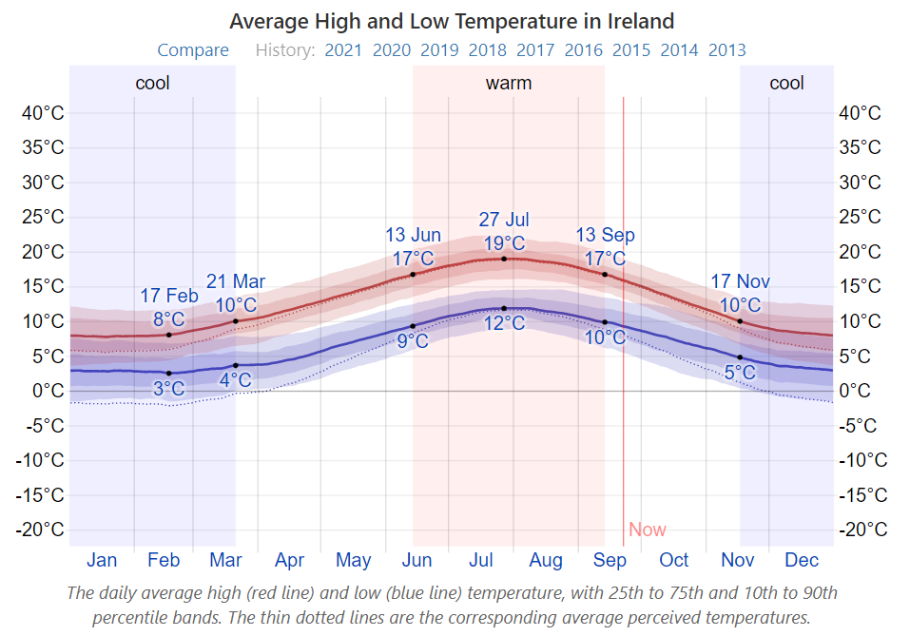
Image 7: Temperature Average

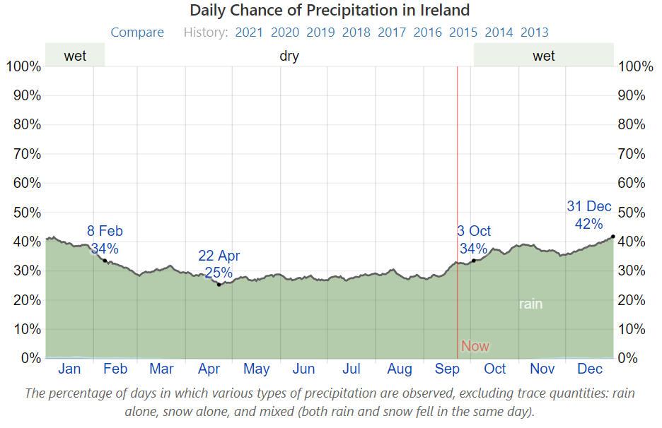

Image 8: Daily Chance of Precipitation

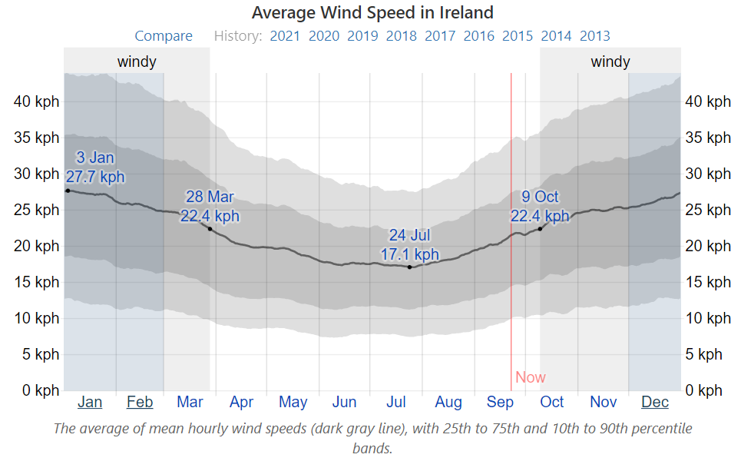

Image 9: Average Wind Speed in Ireland
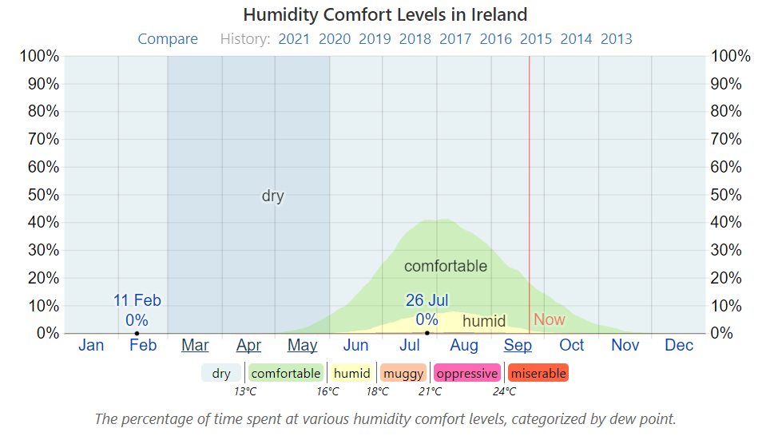

Image 10: Humidity Comfort Levels
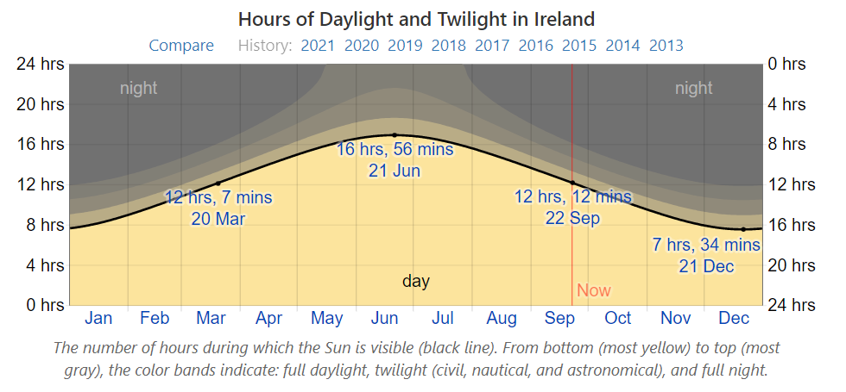

Image 11: Hours of Daylight

3.3.3 Typical Flight Missions uncontrolled Airspace
The initial mission types are described in Table 7 and shown from Figure 13 through to 20. The mission types will either be 2d Mapping or 3D mapping. Manual flights will be conducted for Inspections and the event of the pilot taking control of the drone either during or after a Pre-planned flight mission. Linear Missions will be conducted in the same manner as 2D and 3D missions. The following deconfliction strategies apply:
- 2D/3D Flight Mission max height = 120m AGL Multi-Rotor
- Inspections Flight Missions max height = 120m Multi-Rotor
- Linear Flight Missions max height = 120m AGL Multi-Rotor

N° | Mission Type  Uncontrolled Airspace | Type of area over Flown | Max height  [m]  AGL | Airspace | Type
1 | Topographical (2D/3D) | Sparsely  Populated Areas/Populated Areas | 120 | EINN | VLOS / Automated  (Semi  or manual)
2 | Bridge/Roof/Façade (2D/3D)
3 | Coastal Erosion/Defence/ (2D/3D)
4 | Electrical Substations/Phone Mast/Electrical Power cables (2D/3D)
5 | Waypoint Mission Manual
Table 6: Flight Mission parameters

3.3.3.1 Including new Flight Mission Parameters/workflows
In case of a new workflow for flight mission parameters that may need changing or be required, the following needs to be satisfied:
N° | Mission Type  Controlled/Restricted/Prohibited Airspace | Type of area over Flown | Max height  [m]  AGL | Airspace | Type
1 | Topographical (2D/3D) | Sparsely  Populated Areas/Populated Areas | 120 | EINN | VLOS / Automated  (Semi  or manual)
2 | Bridge/Roof/Façade (2D/3D)
3 | Coastal Erosion/Defence/ (2D/3D)
4 | Electrical Substations/Phone Mast/Electrical Power cables (2D/3D)
5 | Waypoint Missions Manual
- The risk class of the flight mission parameters cannot compromise the level of compliance of the risk assessment in Section 3.
Table 7: Controlled airspace parameters
- The flight mission parameters must be contained in the approved area of operations, Section 3.1.2.
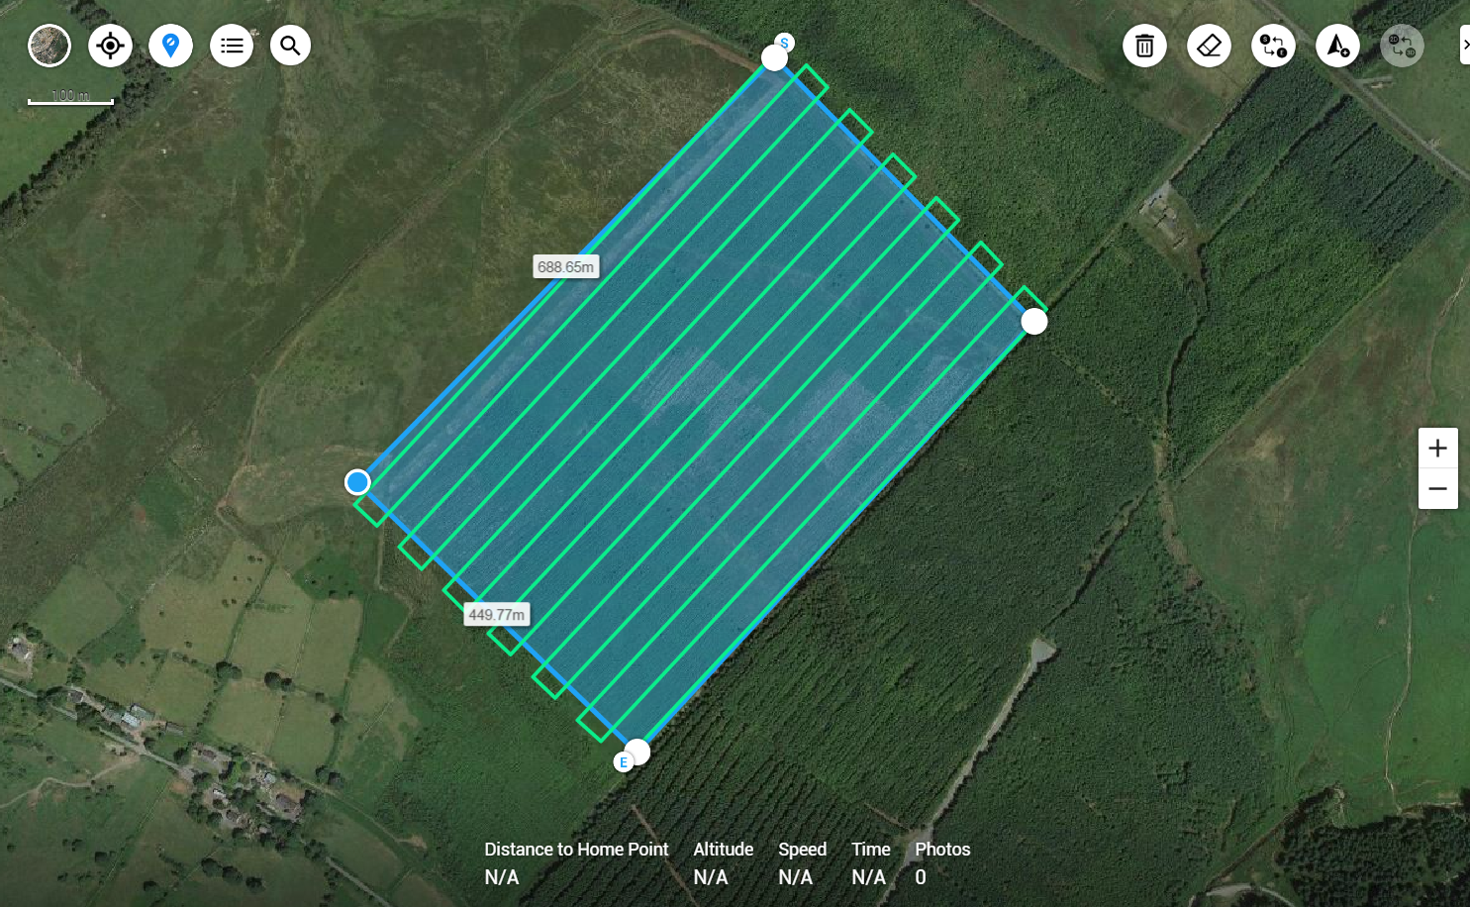
Image 12:Typical Flight Mission 2D

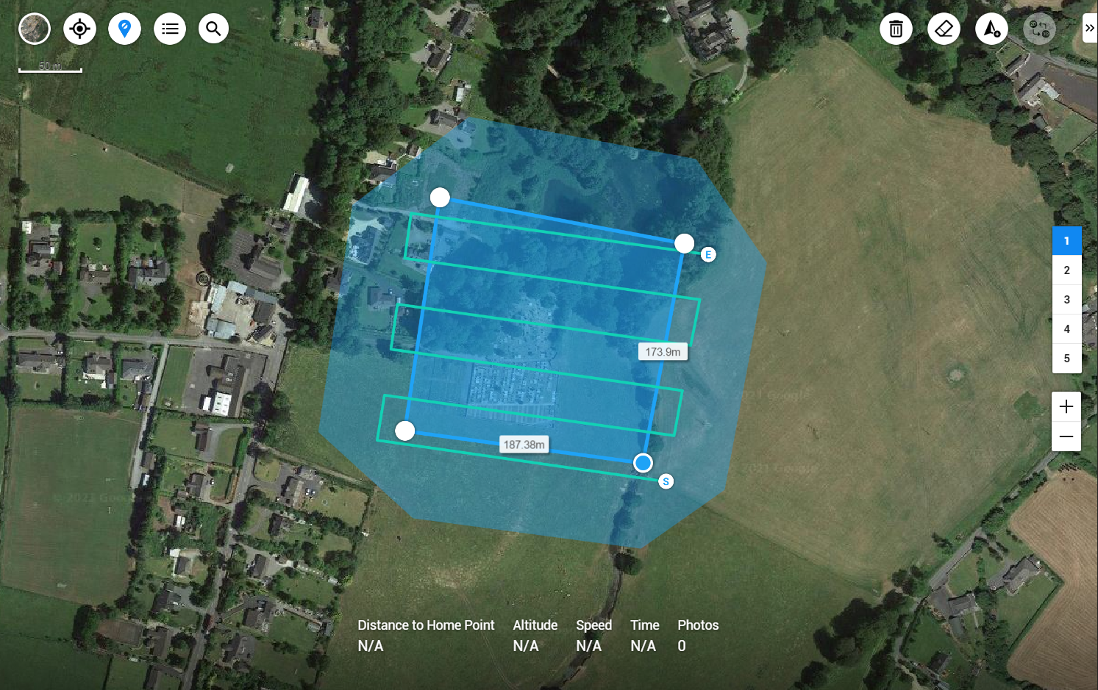
Image 13:Typical Flight Mission 3D

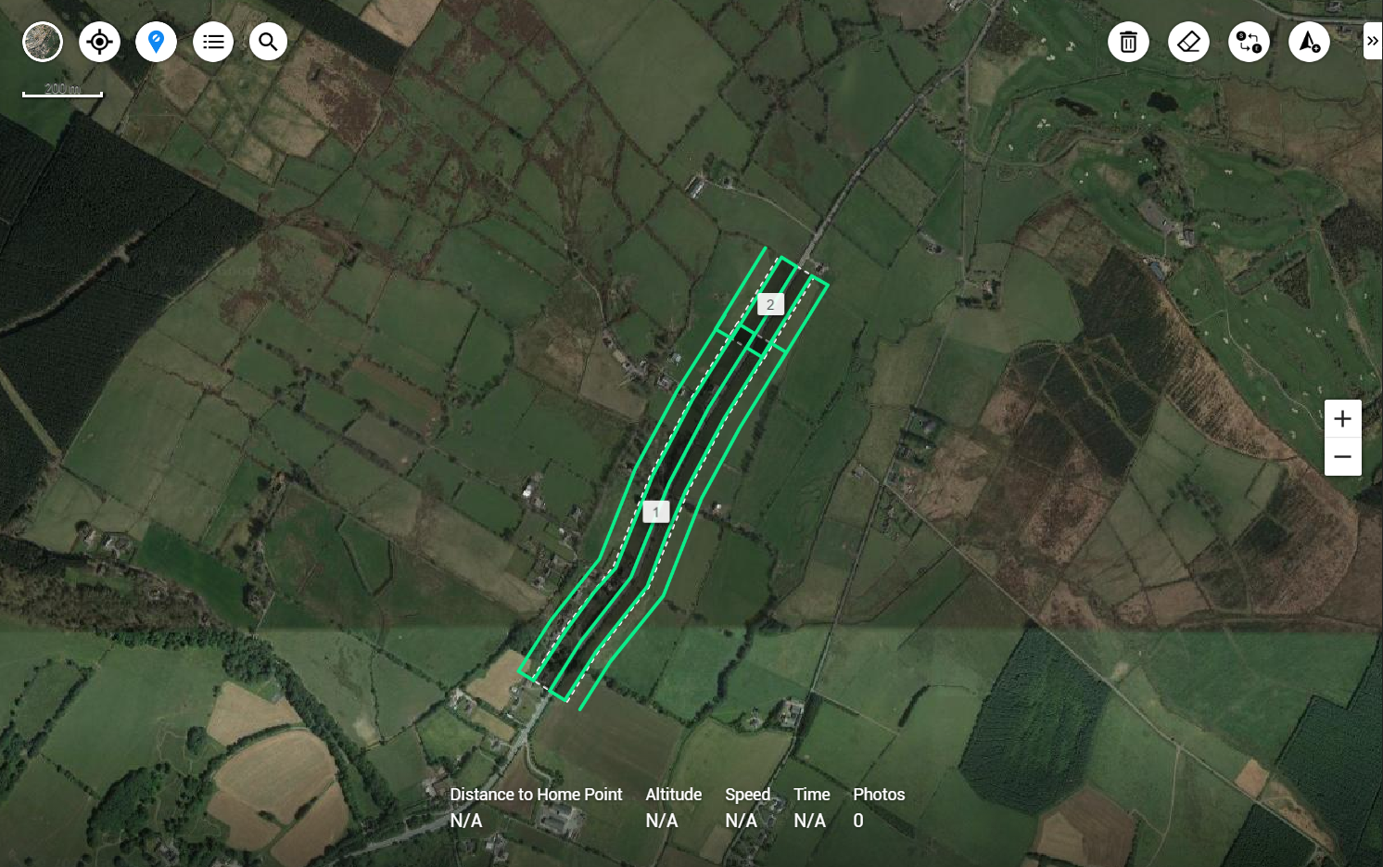
Image 14:Typical Linear Mission

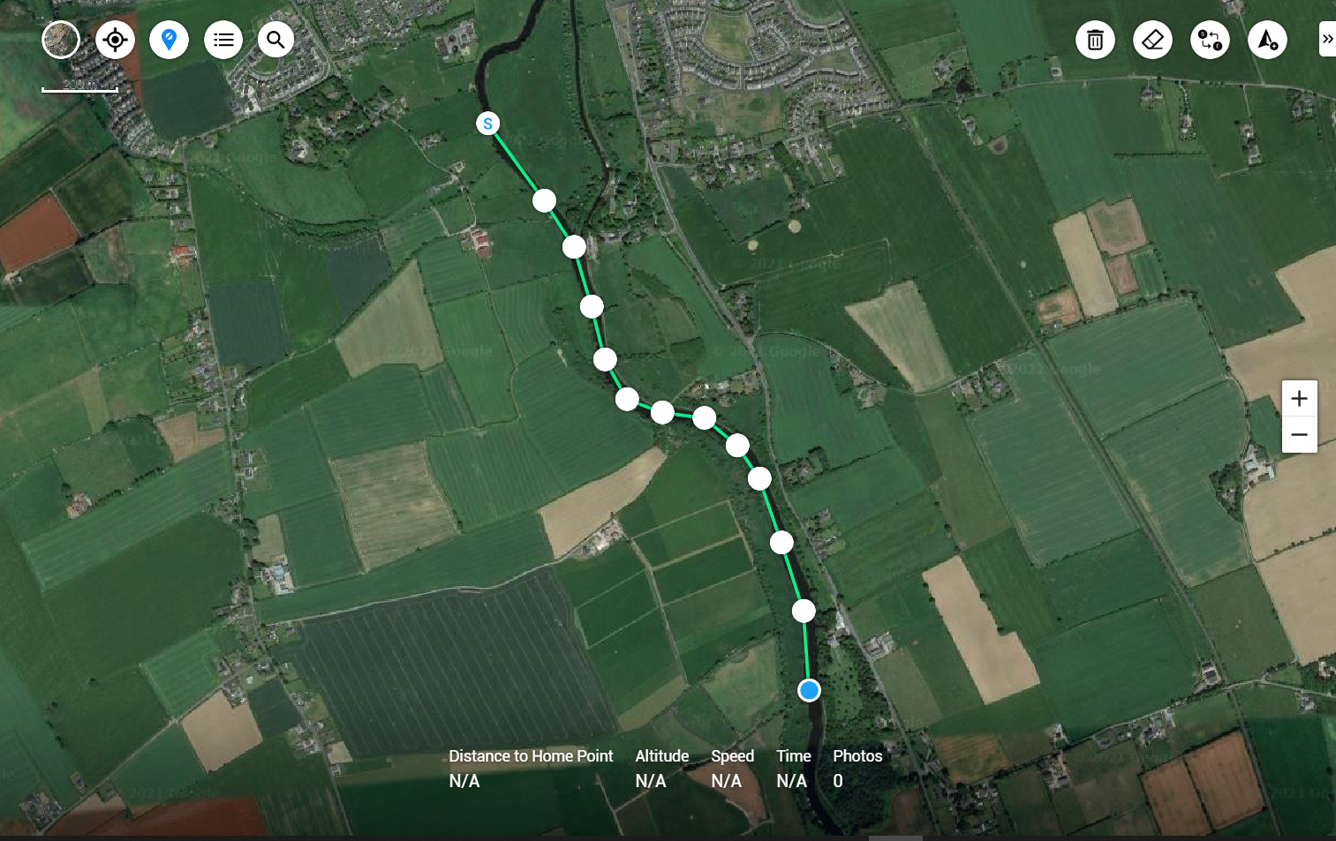
Image 15:Typical Waypoint Mission - Uncontrolled Airspace

3.3.3.2 Typical Flight Missions Controlled/Restricted/Prohibited Airspace

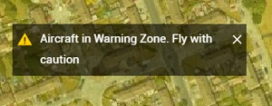
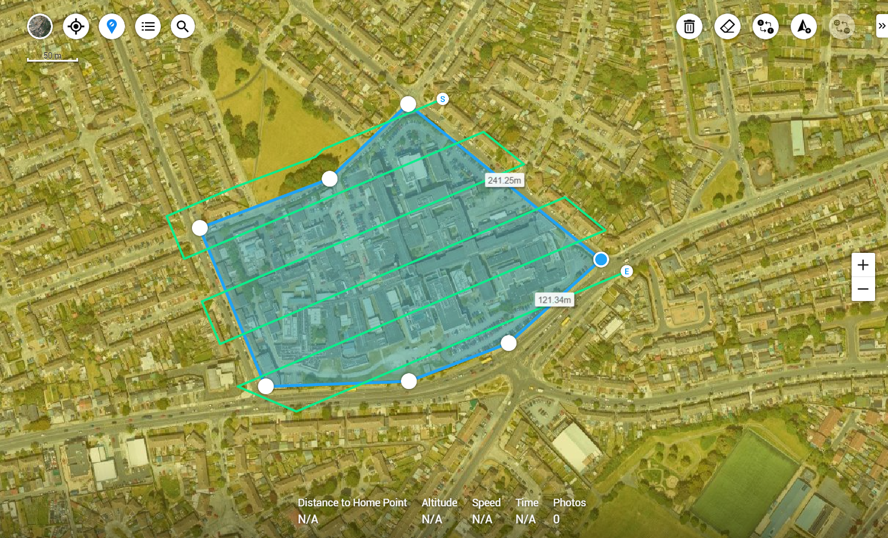
Image 16: Typical 2D Mission - Controlled Airspace
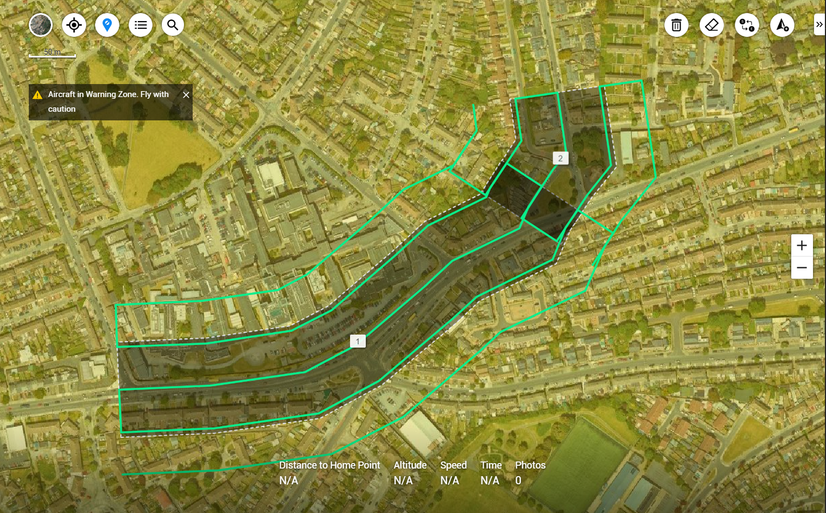
Image 17:Typical Linear Mission - Controlled Airspace

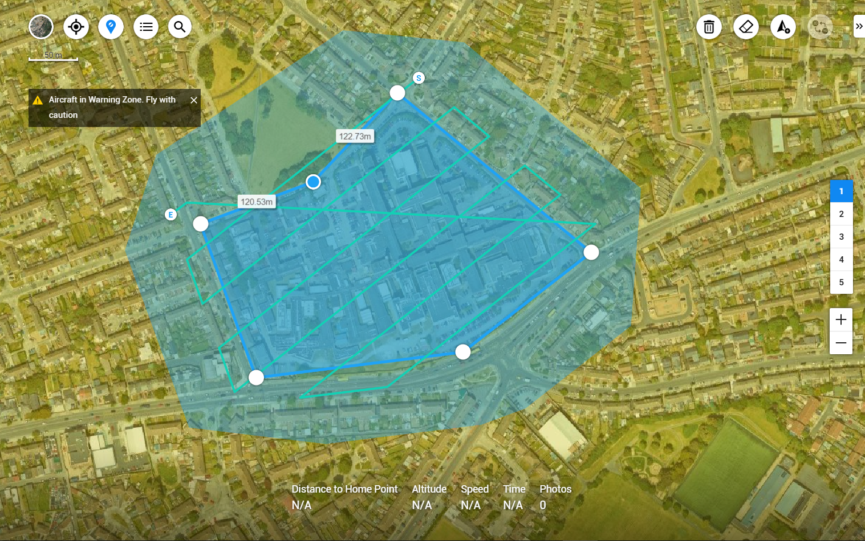
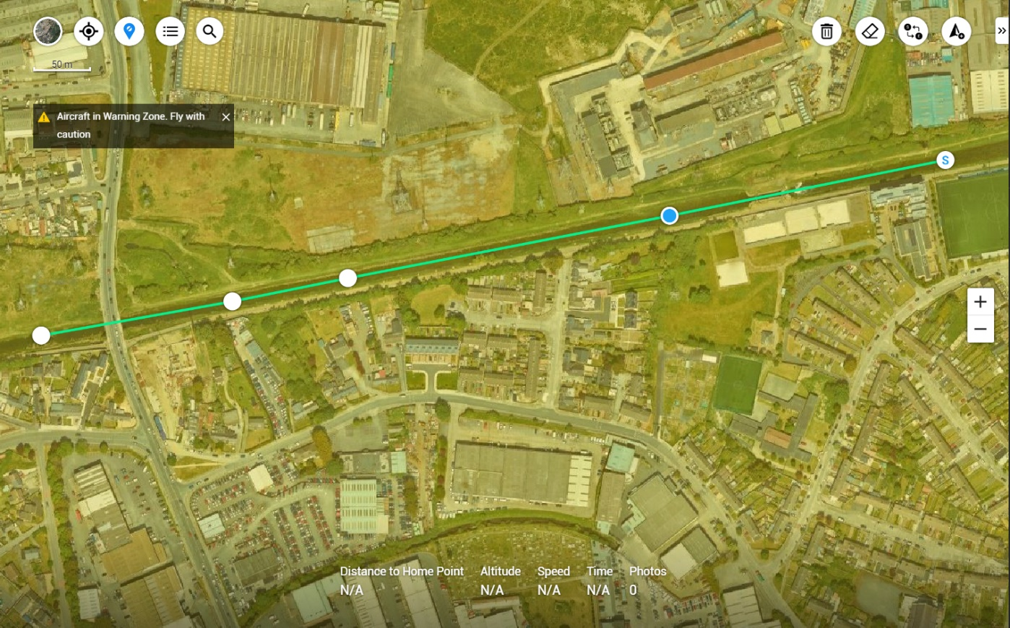
Image 19:Typical 3D Mission - Controlled Airspace
Image 18:Typical Waypoint Mission - Controlled Airspace

3.1.3.4 Containment / Geofence
The operational volume, describe in Section 3, is contained by a polygonal geofence that runs parallel to the horizontal projection of the Mission area and closes the vertical dimension with a ceiling of 120meters. When Operating any Flight Mission within DJI App software DJI GO FLY the App has the ability to generate a GEO-Fence where the Drone will remain inside this GEO-Fence. The Standard Operating Procedure for Your Company Name is when the Flight Radius has been confirmed the RP will then input the horizontal distance and the Vertical Distance for the flight mission. See figure 21 & 22 for example.
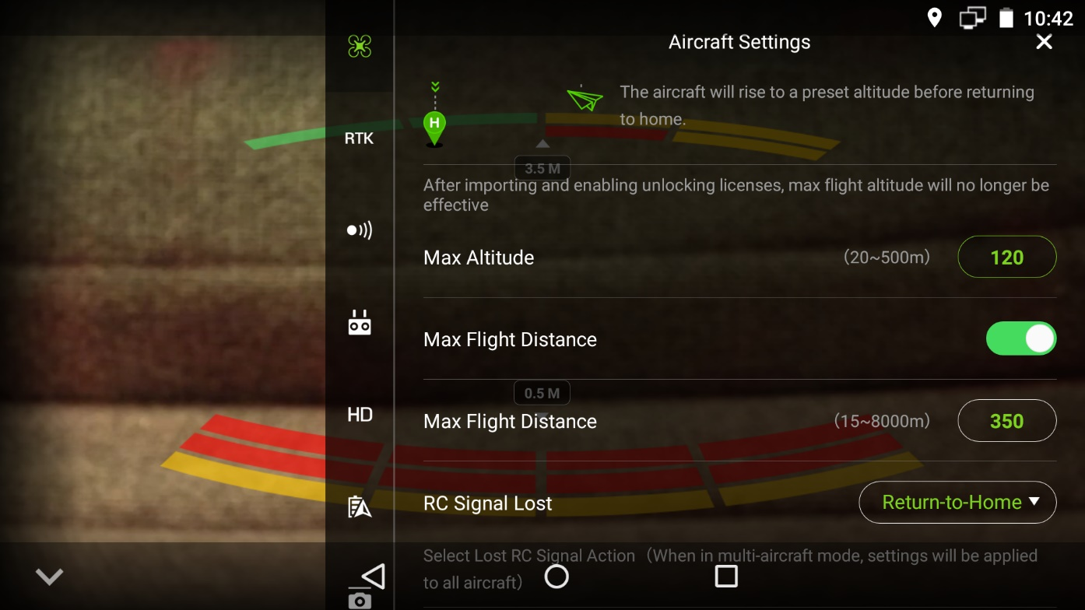
Image 20: Containment/Geo-Fence/Boundary Box in DJI App
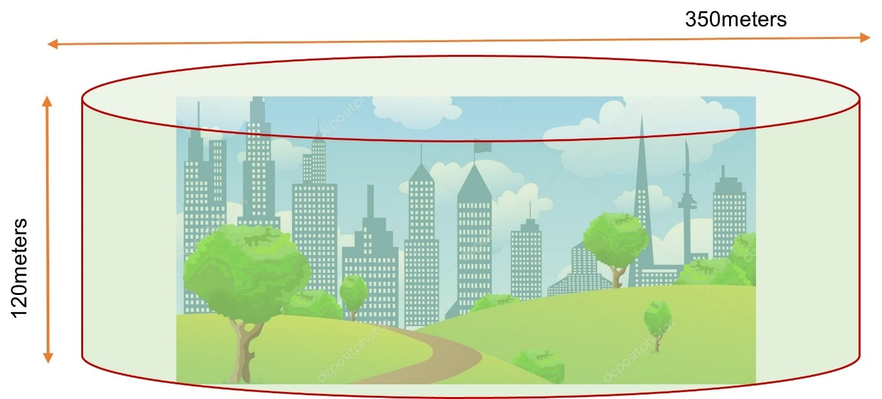
Image 21:Geo-Fence Parameters Diagram

3.3.3.6 Geo-Fences around Airports – DJI FlySafe Geo-App.
The DJI FlySafe Geo-App can be used as a form of Safe Geofencing against certain Flight Emergencies, once GPS is still active. The DJI FlySafe parameter are proven to be very effective when operating within 5Km of the Airport. The DJI FlySafe Parameters will not let a DJI Drone take-off within a 5KM radius of the Main airports in Ireland, Dublin, Waterford, Cork, Kerry, Limerick, Knock. Sligo and Donegal without applying for an unlocking code through the DJI FlySafe Website. In order for a Drone operator to receive the Unlocking code the RP must fill-in an application form and procedure Proof that they have permission from SUAAIRSPACE@iaa.ie to conduct a Drone Operation within 5KM of the Airport. A screen grab of the operations permission from the terms and conditions email will be enough for DJI FlySafe Team. This and the Flight controller Serial Number must be in the Application in order for the RP to get the unlocking codes for the Drone to take-off in this environment. These unlocking codes will then be synced with the Aircraft and the Remote Controller to allow operations to go ahead. When applying for the unlocking codes the flight parameters must be added to the application and these are the parameters that the drone operation will take place under. At no stage will the DJI FlySafe Geo App allow the drone to fly outside of these parameters.
Under RED and BLUE Zones Unlocking Codes are required and can only be applied for through DJI FlySafe Website. There is Time Frames on these Codes. Your flight permission parameters from SUAAIRSPACE@iaa.ie with location, radius, flight height and date time group will be the DJI FlySafe Parameters. You will not be able to operate outside of these parameters. This is per application.

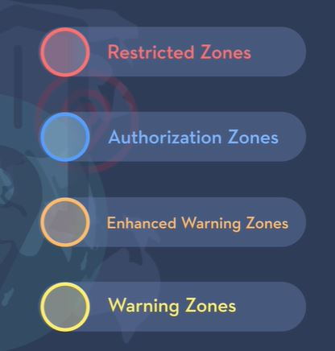
Image 22:DJI Flysafe Geo-Zones
Enhanced Warning & Warning Zones only require the Pilot to tick a box to acknowledge they are operating in these Zones. When operating in these Zones the RP will input the Mission Parameters as described in 3.1.3.4 Containment / Geofence.

3.3.4 Level of Involvement (LoI)
Although the RP is always in control of the UAS, the missions that are conducted with third party Flight Planning software or Third-Party Flight planning Apps, are semi - automated. The mission is uploaded to the flight controller with information on the navigation waypoints. Actions under normal, abnormal, and emergency situations will be conducted by the RP. However, the crew is present to watch for the safety of the flight and participates actively during the nonautomated parts of the operation if any.

The crew is involved in the following way:
- Remote Pilot will:
- Make sure Mission parameters are correct
- Checks Containment Fences / Geo-Fences are in place and correct.
- start, flies, interrupts and / or terminates the flight.
- monitors the flight, communicates with the VO (If Present), and executes commands under normal, abnormal, and emergency situations.
- takes manual control of the UAS under abnormal and / or emergency procedures in VLOS.
- Visual Observer If Present will: (If not these are added involvement for the RP)
- secures the site, handles the insertion of SD Card, and enhances the situation awareness of the RP during VLOS Operations.
- Become the crew member on site if the external workload exceeds the capabilities of the RP or on request from the RP.
The Remote Pilot must be aware of external particulars that may influence any aspect of the Drone Operation. The RP must have contingence plans in place. See OM Section 5. Contingency Procedures.

3.3.5 Normal Operation Strategy
The normal operation strategy consists of 4 phases through which the readiness of the crew and UAS is evaluated until the final roll out of full-scale operations.

3.3.5.1 Flight Planning – Mission Brief.
During the Flight Planning phase, the crew gets familiar with the intended area that requires drone flights. The following goals are to be accomplished:
- Approval of Drone operation from Head of Drone Department.
- Mission Area / Working area to be defined.
- KML of Mission Area / Working Area to be confirmed and checked correct.
- Deliverables to be issued to Remote Pilot and processor.
- Drone Pilot and company Processor to discuss data collection of Mission parameters.
- The training of new crew members if not completed already.
- Test the readiness of the UASs in VLOS. (Only if UASs not flown in the last two weeks.)
- Brief issued to Remote Pilot that is going to be conducting the Operation/Project.
- Questions and Answers session from Drone Pilot to Chief Drone Pilot (if required)

3.3.5.2 New Environment parameters
During the new environment parameters phase the crew continues its training and keeps on building up confidence in getting to know the system and the new environment from the Flight Planning phase or simply by being on site and conducting the following to ensure the new environment is safe:
- The new environment sites are visited in person either on the day they are required to be flown or if certain permission is requested to personally go and visit the site to conduct the following:
  - Identify local hazards.
  - Select a suitable landing area.
In case the new environment sites are not accessible due to COVID 19 restrictions, the RP will be requested to use all the Flight Planning features that is available to them to get a view and understanding of the new site. If the site is new to a particular Remote Pilot but not to the company and it has been flown previously then the previously Orthomosaic will be requested, and the new RP will familiarise themselves using this Orthomosaic in conjunction with Goggle Earth PRO. The new RP will touch base with the previous RP that has flown this Site and a Questions and Answers Session will be held between them.
- Important questions will be asked such as:
  - What are the communications on this Site?
  - What is the terrain like for take-off and landing on all the UAS Systems Your Company Name have to offer?
  - Range assessment of the UAS in the new operational environment.
  - Type of airspace and what usage of manned aircraft are operating in this airspace, whether it be Controlled or Uncontrolled.
  - Is the manned aircraft operating in the area of a?
    - Low Risk
    - Medium Risk
    - High Risk
    - Consider a TRA if Manned aircraft is of a High Risk
  - Type of ground risk is it densely populated or sparsely populated.
  - What other Air users are operating in this new environment?
    - Parachutists.
    - Ballooning.
    - Hand Gliding.
    - Para Gliding.
    - Drone Operators Commercial/Hobbyists.
    - Emergency services.
    - Is there Airspace restrictions from manned or unmanned aircrafts in place for this new environment.
    - Is it on the path of migrating Birds?
If needed and the request is approved the previously RP, that has flown this environment, will be present while the New RP to this Environment completes their flight missions.

3.3.5.3 Flight Mission Validation.
During the Flight Mission Validation (FMV) phase the following with be checked:
- The RP are trained and validated, and the Operational Authorisation is current under new EU rules and regulations.
- The Mission parameters flight altitude are confirmed and are adjusted and validated to use within the Working Area and DJI App Parameters that the RP has imported.
- Certain Flights Missions can be validated if have been flown before.
- Almost all FMV will be carried out while Mission has been flown by RP, once points one and two are confirmed.

The duration of the validation phase depends on the background of the crew and complexity of the environment.

3.3.5.4 Full-Scale Operations
Once all the training of staff members is complete and an Operational Authorisation under the Specific Category has been issued to Your Company Name then full-scale operations can begin. During this phase all Drone operations are carried out and approved by the Head of the Department who will inform the Chief Remote Pilot of any changes that maybe required.

3.3.6 Standard Operating Procedures
In this the following topics are presented:
- Operational information related to Normal Missions.
- Modifications or supplements to the existing procedures, roles or responsibilities stated in the OM.

3.3.6.1 Normal Operating Procedures
The following normal procedures are defined in order to account for adaptations of those stated in the OM, (Section 4 – Normal Procedures).

3.3.6.2 Flight Preparations
Modifications or addition of procedures during the flight preparations are presented below.

3.3.6.2.1 TRA
If a Temporary Restricted Area is to be issued for any operation this will be submitted with a 90-day lead in time as requested by ANSP of the IAA. All Staff must know how a TRA operates prior to any Operations to be conducted under a TRA. A full operational briefing will be held if any Drone Operations are to be conducted under a TRA.

3.3.6.2.2 NOTAMs
The RP shall use the following link of to obtain official NOTAM information on the area of operations:
https://www.iaa.ie/air-traffic-management/notam
NOTAM must only come from the official Irish Aviation Authority website.

3.3.6.2.3 Flight Scheduling – with client.
The flights date time group will be discussed with the client at management level and are scheduled between Your Company Name and the client through telephonically or via email, preferably with enough lead in time for the Remote Pilots to plan and prepare all documentation before drone Operations commence.

The Make and Model of the Drone will be allotted to the Remote Pilot at this stage of the Operations. It will be their reasonability to have the correct equipment in working order and any permissions that might be required for the Project.

3.3.6.2.4 Legal and Permissions
The RP must confirm that the following documents are present and valid:
- Operational Authorisation
- RP have their Open/Specific Category licence valid
- NOTAMs checked
- TRA (If Required)
- Insurances of the Your Company Name
- If Client requests a RAMS, H&S of Your Company Name to complete and send on to client/RP/Chief Remote Pilot.

3.3.6.3 Pre-Flight
Modifications or addition of procedures during the pre-flight are shown below.

3.3.6.3.1 Weather forecast
During the planning phase of the flight the RP will check weather apps for localised weather. The following Apps to be checked in particular for the following limitations:
Light, windspeed, Cloud base, Visibility, Temperature, Wind gust, difference in wind at 10m, 50m, 100m, Rain radar and forecasted.
- Met Eireann
- Ventusky
- Windy
- Google Weather
The boundary parameters are to be defined as follows:
- max wind speed on take-off = 10 m/s
- max wind speed in cruise = 10 m/s
- max horizontal gust speed = 10 m/s
- max probability of rain prediction = Not to be flown in Rain
- Cloud base = 120m/400ft
• if visibility is less than = 800m. (NO GO in VLOS)

3.3.6.4 Flight Execution
Modifications or addition of procedures during the flight execution are presented below.

3.3.6.4.1 Weather monitoring
The RP shall use Windy/Ventusky or Met Eireann to monitor the rain radar.

3.3.6.4.2 DJI App/eMotion Software
The RP shall use the DJI Sense and detect system in the App to spot and monitor other aircraft during the flight operations.

3.3.6.5 Contingency and Emergency Procedures
Besides the following, there are no modifications to those stated in the OM.

3.3.6.5.1 Contingency procedures
As laid out in Section 5.0 of this manual

3.3.6.5.2 Loss of Connection with the DJI Ap
Image 23:Loss of Connection with DJI App Software
Loss of Connection with DJI App
Time Without connection
Reconnected
NO Reconnection
Continue with Mission
App will Trigger Return to Home. RP will also trigger

3.3.6.6 Occurrence Reporting
As laid out in Section 10 of this manual

3.3.6.7 Operational Limits

3.3.6.7.1 Altitude and Height
The Flight Missions are planned at different heights between the 0 and 120 m AGL. This height limitation may not be always satisfied due to different characteristics of the Project, if there is a requirement to conduct operations above 120meters AGL Permission will be requested through the IAA.

3.3.6.7.2 Times of Operations
The operations shall only take place during the day. Although the UAS is equipped with navigations lights and does not require visual aids for navigation, the procedures stated in this section are conceived for operations during the day light only.

3.3.6.7.3 Weather
The following weather limitations are applicable:
- Wind: When conducting any flight mission, the max limitation for wind is 10m/s on both Multi-Rotor Drone operations.
- Rain: No flight shall take place if there is predicted rain along any of the flight missions’ operational areas or during the time of the mission. If UAS is in a flight mission and downpour happens RP will Return to Home with the aircraft. RTH will not be triggered. RP will fly the drone back under control if it’s the Multi-Rotor.
- Visibility: minimum horizontal visibility = 800m.
- Could Clearance: with a minimum ceiling of 120m.

3.3.6.7.4 Crew
The minimum number of crew members is different depending on the nature of the operation:
- For Multi-Rotor flights that are deemed Low or Medium Risk operations:
  - 1x RP
- For Multi-Rotor flights that are considered High Risk operations
  - 2 X RPs

3.3.6.7.5 Telemetry Timeout
If while conducting Drone Operations and the RP Telemetry goes blank and no live feed is being reported back to the Remote Controller, if the RP cannot get a positive connection, they will terminate the flight and trigger the Return Home Function. The time frame to make this decision will be less than 30 seconds. The RP will reboot the Remote Controller Tablet/SmartController/iPad/Phone it will take longer than 30 seconds to reboot, the RP will monitor the Aircraft and if it starts to go off mission flight lines, he will trigger RTH Function immediately.

3.3.6.8 Emergency Response Plan
See Section 7 for further information on the Emergency Response Plan
N° | Station | Telephone | Contact Person
1 | Police, Fire, Ambulance | 112 or 999 |  | -
 | Air Traffic Control
2 | Dublin – 01 8144601 Waterford – 051 850341 Sligo – 071 9168461  Baldonnell – 01 4037514 Cork – 021 4237853 Shannon – 061 471868  Weston – 01 6217301
3 | IAA | +353 86 605 1122 | Lou Fine
Table 8: Emergency Phone Contacts
The fire, ambulance and police services in Ireland are all contactable via the above numbers. When calling emergency services, you will need to provide the following:
- The exact address of the incident or emergency and/or any noticeable landmarks nearby.
- Directions to the scene of the emergency.
- The telephone number you are calling from.
- Details on the incident itself, the number of persons involved, the description, any visible injuries and knowledge of any pre-existing medical conditions.
Try to stay calm and listen to the call taker’s instructions.
It is also important to keep your own phone on as the emergency service may need to contact you for further information. The RP shall use Table 11 to write down relevant information prior the call:

3.4 SORA - Specific Operating Risk Assessment for Risk analysis and methods for reduction of identified risks
The SORA analysis is performed using the information provided in SORA EU 2019/947. To facilitate the comprehension of this Section, the reader is recommended to follow the guidelines of the SORA analysis stated in EU 2019/947(Figure 25 Table 4).

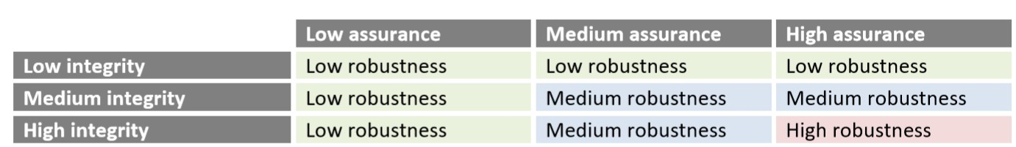
The robustness of the proposed mitigations is determined using Figure 25.
Image 24: Determination of Robustness Level SORA EU 2019/947 (Table 4)

3.4.1 Applicability
As stated in the SORA (see Figure 25 Table 4):
- The methodology presented in this document is aimed at evaluating the safety risks involved with the operation of UAS of any class, size, or type of operation.
- The safety risks associated with collisions between UA and manned aircraft are in the scope of the methodology. The risk of a collision between two UA or between a UAS and a UAS carrying people will be addressed in future revisions of the document.
- In the event of a mishap, the carriage of people or payloads on board the UAS (e.g., Weapons) that present additional hazards is explicitly excluded from the scope of this methodology.
- Security aspects are excluded from the applicability of this methodology when they are not limited to those confined by the airworthiness of the systems (e.g., the aspects relevant to protection from unlawful electromagnetic interference.)
- Privacy and financial aspects are excluded from the applicability of this methodology.
- The SORA can be used to support waiving the regulatory requirements applicable to the operation if it can be demonstrated that the operation can be conducted with an acceptable level of safety.
- In addition to performing a SORA in accordance with the UAS Regulation, the UAS operator must also ensure compliance with all the other regulatory requirements applicable to the operation that are not necessarily addressed by the SORA.

3.4.1.2 Company RAMS (Risk assessments and Method Statements).
Company policy is that all drone operations cannot be conducted without a Company RAMS to be completed prior to operation. These RAMS must be submitted to Safety Manager for review and must be submitted to client prior arrival on site for their approval. Please see company Document RAMS ver1.2 this is the document that all Drone Parties weather Third party or company Drone operations must fill in before any drone operations.

3.4.2 Ground Risk
The ground risk estimation is the determination of risk of a person being struck by the AUV in case of loss of control with a reasonable assumption of safety.

The GRC determination is summarized as:
- Based on the nature of the operation the IGRC = 4
- The level of robustness of the proposed mitigations enables a reduction on the IGRC of -1 points.
- The mitigated GRC is = 3.

3.4.2.1 Determination of Intrinsic Ground Risk
The kinetic energy of the Mavic 2 Enterprise Advanced is estimated as follows:
𝐸_{𝑐} =𝑚𝑣²
With m = MTOW = 907g and v = airspeed = 5m/s, Ec = 11.3375 J. Therefore the 1st column (<700J) in Figure 26 is chosen.

- The operational scenario is a VLOS flight over sparsely populated environment.
Combining both the operational scenario and the kinetic energy, the intrinsic UAS ground risk is:
IGRC = 2
- The operational scenario is a VLOS flight overpopulated environment.
Combining both the operational scenario and the kinetic energy, the intrinsic UAS ground risk is:
IGRC = 4
Overall IGRC
The overall IGRC for the different types of Operations.
VLOS in a Sparsely Populated environment is 4 for all drones and for Operations in VLOS in a populated environment is 2 for all drones.

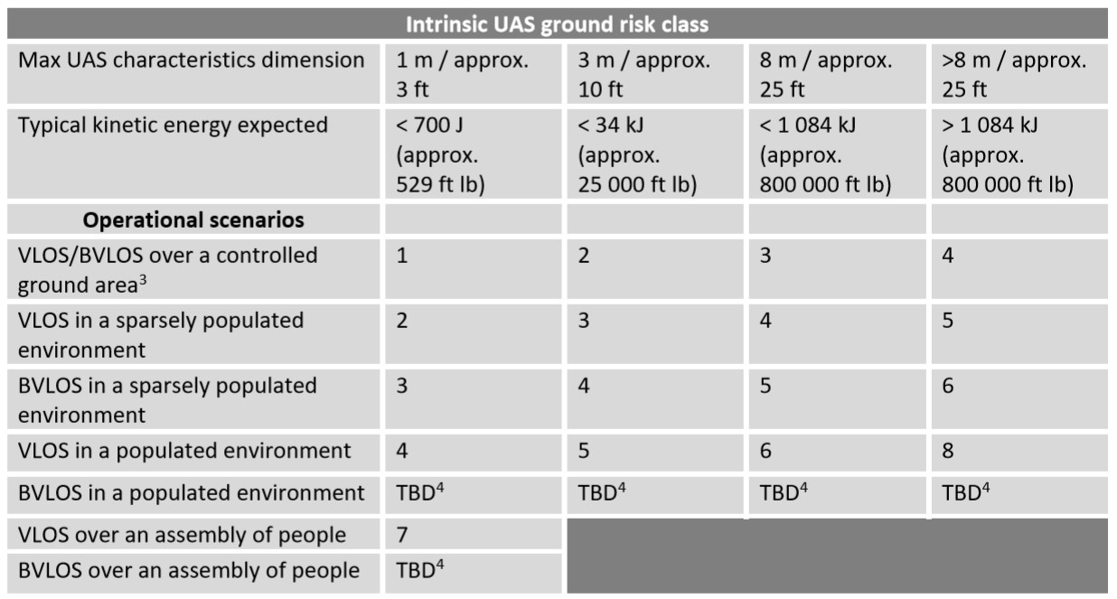
Figure 25: Intrinsic Ground Risk Class (SORA EU 2019/947 Figure 25 Table 4)

3.4.2.4.1 Determination of Mitigated Ground Risk
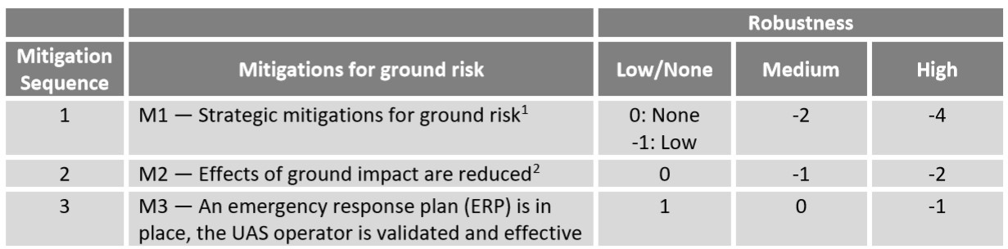
Figure 26:Mitigations for final GRC Determination (SORA EU 2019/947 Figure 25 Table 4)
The summary of the robustness determinations is presented in Table 13.

Mitigation Sequence | Mitigations for Ground Risk | Robustness | Correction Factor
1 | M1-Strategic mitigations | Medium | -2
2 | M2- Effects of ground impact reduction | Low | 0
3 | M3- ERP | Low | 1
Table 9: Ground Risk Mitigation Robustness
The mitigated ground risk category is calculated as the addition of the intrinsic ground risk and the corrections factors of Table 13.

With IGRC = 2, M1 = -2, M2 = 0 and M3 = 1, the mitigated risk category is:
MGRC = 1

3.4.2.4.2 M1-Reduced Affected People
M1 Strategic Mitigations for Ground Risk

Level of Integrity: This Integrity has two Criterion 1. Definition of the ground risk buffer & 2. Evaluation of people at risk

Criterion 1. Definition of the ground risk buffer

The Ground Risk Buffer is defined as:
The Flight Geography of the Drone Flight area
The Contingence Area for the use of Contingencies laid out in Section 5
The Ground Buffer Area for the Use of Loss of Control of the Mission
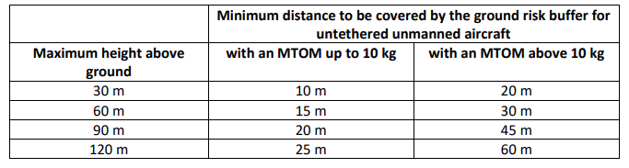
NOT TO BE USED

Criterion 2. Evaluation of people at risk
The applicant evaluates the area of operations by use of authoritative density data (e.g. data from the U-space data service provider) relevant for the proposed area and time of operation to substantiate a lower density of people at risk. If the applicant claims a reduction, due to a sheltered operational environment,
the applicant:
(a) uses a UA of less than 25 kg and not flying above 174 knots, and
(b) demonstrates that although the operation is conducted in a populated environment, it is reasonable to consider that most of the non-involved persons will be located within a building.
Based on the above:

Level of integrity M1: Medium

Level of assurance: This Assurance has two Criterion 1. Definition of the ground risk buffer & 2. Evaluation of people at risk

Criterion 1. Definition of the ground risk buffer:
The Ground Risk Buffer is defined as:
The Flight Geography of the Drone Flight area
The Contingence Area for the use of Contingencies laid out in Section 5
The Ground Buffer Area for the Use of Loss of Control of the Mission.

Below is all our Operations and how the Ground Risk Model is applied.
- 2D/3D Mapping, General Photography and Videography
- Bridge/Structure Inspections
- Asset Management
- Monitoring of Traffic
- Coastal Erosion/Defence/Flooding/Subsidence
- Quarries/Construction sites
- National, regional & Local roads
- Emergency Services Operations

(NB*)
Point to Note:

Here is were you will show the ground risk model for each and every type of operation. Below is just an example of how to apply the Ground risk model. In Criterion 2: Evaluation of people at risk you will have to input in text the information. I have an example that you can use for this type of operation. You will have to do the same for every type of operation. Above are just some of the different types of operations that you maybe involved in.

2D/3D Mapping and General Photography & Videography.
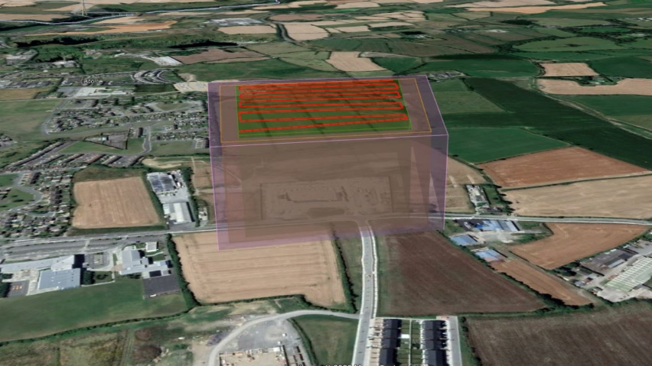
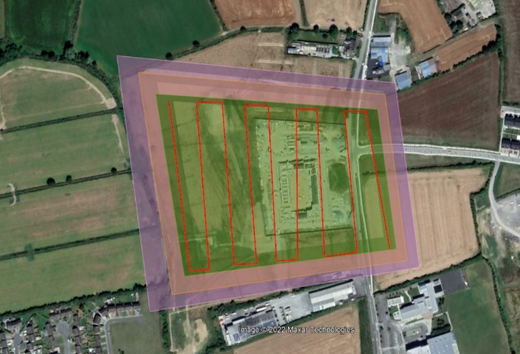

This is a typical Ground Risk Buffer Model for 2D/£d Mapping & General Photography.

Criterion 2. Evaluation of people at risk:
the applicant:
(a) uses a UA of less than 25 kg and not flying above 174 knots or 89m/s, and
(b) demonstrates that although the operation is conducted in a populated environment, it is reasonable to consider that most of the non-involved persons will be located within a building.

The UAS types used for all UAS operations within Your Company Name are below 25Kg and do not fly above 174knots/89m/s. a list of these UAS can be found in section 3.5 Technical Means

The following Operations all have a Ground Risk model where no non-involved person(s) will be unprotected, either they will be located inside a building or vehicle or wearing of PPE which is that of the likes a Hard hat, or Crash Helmet.

2D/3D Mapping, General Photography & Videography
When conducting Drone operations for Mapping, General Photography & Videography, Most sites will be outside of a populated area, when operations are required to be conducted in populated area, the Ground Risk Model will be applied to so no uninvolved persons will be within the Ground Risk Buffer. The flight height will be different for each operation. So, the Ground Risk Buffer will change accordingly, please refer to Table in Level of integrity Criterion 1. Definition of the ground risk buffer.

The Type of UAS will be taken into consideration when flying these locations of populated areas, the use of a lower weight category drone will be utilised in these areas. For general Photography & Videography in a populated area the Mavic 3/Mavic 2/Mavic Air will be used. These are all less than 1kg and the kinetic energy in the unlikely event of loss of control, is less than 46 joules at 10m/s.

When conducting this type of UAS operation the maximum flight speed will be 10m/s. if the UAS operator needs to go faster the Area below the Operation must be fully controlled with on Uninvolved person(s) present.

A Based on the level of assurances of both Criterions above:
Level of assurance for M1: Medium
Based on the above, the overall level of Robustness for M1 is:
Medium with a Correction Factor of -2

3.4.2.4.3 M2- Effects of ground impact reduction
M2 Effects of Ground Impact reduction

Level of Integrity: This Integrity has three Criterion 1. Technical Design 2. Procedures, if applicable, 3. Training, If applicable.

Criterion 1. Technical design
(a) Effects of impact dynamics and post impact hazards are significantly reduced although it can be assumed that a fatality may still occur.
(b) When applicable, in case of malfunctions, failures or any combinations thereof that may lead to a crash, the UAS contains all the elements required for the activation of the mitigation.
€ When applicable, any failure or malfunction of the proposed mitigation itself (e.g. inadvertent activation) does not adversely affect the safety of the operation.

Criterion 2. Procedures, if applicable
Any equipment used to reduce the effect of the UA impact dynamics is installed and maintained in accordance with the manufacturer’s instructions

Criterion 3. Training, if applicable
Personnel responsible for the installation and maintenance of the measures proposed to reduce the effect of the UA impact dynamics are identified and trained by the applicant

Based on the above:

Level of integrity M2: Medium

Level of assurance: This assurance has three Criterion 1. Technical Design 2. Procedures, if applicable, 3. Training, If applicable.
(NB*)
Point to Note:

Here is were you will add any Flight Termination systems details or parachute for your aircraft. I have an example of how I have completed this with the M300

Criterion 1. Technical design
Above in 3.4.3 Ground Risk is the list of Drones and their Kinetic Energy which is estimated without any reduced Impact System. The highest speed for the drone mapping on any Your Company Name Construction site will be no more than 10m/s (36kmph), the highest speed for Manual flying will also be 10m/s (36Kmph) for Multi-rotor Drones less than 4KG. Flight Speeds for fixed wing UAS and heavier UAS Operations can vary.

Because the M300 RTK is the heaviest UAS that Your Company Name have. Here is the kinetic energy of the Matrice 300 RTK which is estimated without any reduced Impact system as follows:
𝐸_{𝑐} =𝑚𝑣²
With m = MTOW = 9Kg and v = airspeed = 12m/s, Ec = 648J. When operating the M300 RTK it will have a Parachute System & Flight Termination System installed.

Therefore Your Company Name feel the need for a Fail-Safe System for the M300 RTK Multi-Rotor Drone. For some operations that are deemed high risk in relation to the amount of unprotected uninvolved persons on or around a site, Your Company Name will decided at their will, whether to operate with a Parachute & Flight termination System. For Operations in congested areas the Fail-Safe System will be utilised. The Fail-System Your Company Name have opted for is the Flyfire OWL system. All Staff members who operated the M300 RTK will receive correct training on this system, by a third-party training company.

Criterion 2. Procedures, if applicable
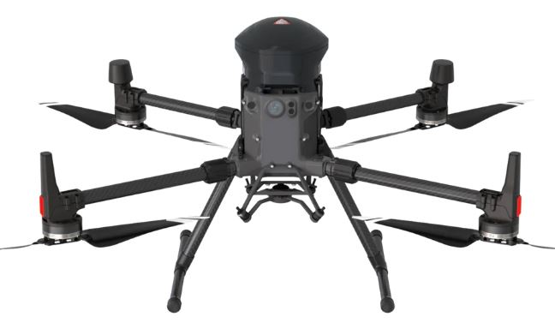
Any equipment used to reduce the effect of the UA impact dynamics is installed and maintained in accordance with the manufacturer’s instructions safety.

OWL is equipped with Flyfire safety algorithm, and the hazard response time is lowered to 0.5 seconds. In case of emergency, the parachute can also be opened manually. The speed is stabilized at 3.5m per second. (test weight 9 kg). During the forced landing, the high-power buzzer continuously sends out the 110DB warning sound to remind pedestrians on the ground to avoid and protect their safety.

Criterion 3. Training, if applicable
Personnel responsible for the installation and maintenance of the measures proposed to reduce the effect of the UA impact dynamics are identified and trained by the applicant. Third Party Training Organisation/ DUTO will providing Your Company Name with the required training on the operation of this system to its Remote Pilots.
Level of assurance for M2: Medium
Based on the above, the overall level of Robustness for M2 is:
Medium with a Correction Factor of -1

3.4.2.4.4 M3- Emergency Response Plan
M3 An ERP is in place, UAS operator validated and effective

Level of Integrity: Criteria
The ERP:
(a) is suitable for the situation.
(b) limits the escalating effects.
(c) defines criteria to identify an emergency situation.
(d) is practical to use.
(c) clearly delineates the duties of remote crew member(s).
Level of integrity M3: Medium

Level of assurance: This Assurance has two Criterion 1. Procedures & 2. Training

Criterion 1. Procedures:
The Competent Authority have no guidelines or standards required for the ERP. However “common sense” has been applied in relation to the development of the ERP with the help of our inhouse qualified Health and Safety staff. Your Company Name Drone Pilots conduct a Tabletop exercise once every six months.
- the outcome of the situation relies highly on providence; or
- It could not be handled by a contingency or emergency procedure; or
- when there is a grave and imminent danger of fatalities.
- It is of practical use since it is schematic and simple.
- It describes the role of the crew members.

Criterion 2. Training:
The ERP tabletop exercise is recorded and saved. A record of this training is kept up to date.
Level of assurance for M3: Medium
Based on the above, the overall level of Robustness for M3 is:
Medium with a Correction Factor of 0

3.4.3 Air Risk
The air risk estimation is the determination of risk of mid-air collision with other manned aircraft with a reasonable assumption of safety.

The Air Risk is determined by following the flowchart
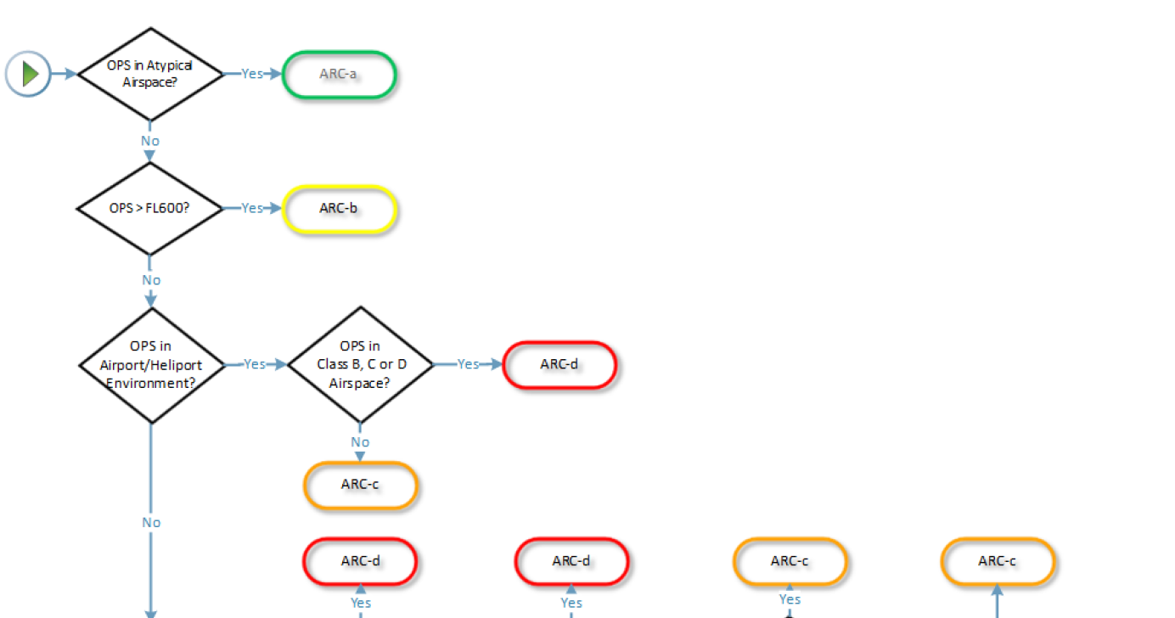
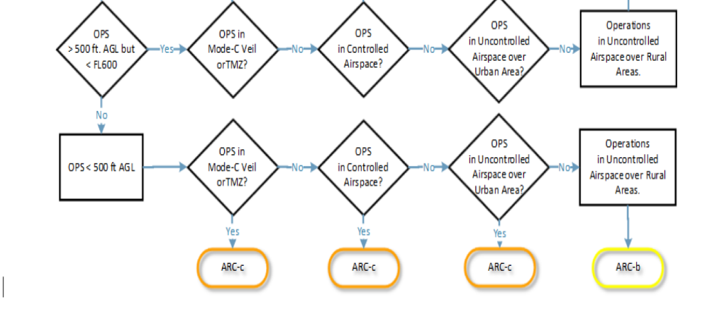
Image 28:Air Risk Class Category

3.4.3.1 Determination of Initial Air Risk Class
The operation as described in 3.1.2, takes place in:
- Below 400ft AGL
- Controlled airspace with Permission.
- Temporary Restricted Areas with Permission.
- Air Traffic Zones with Permission.
- Restricted/Prohibited Airspace with Permission.
- In airspace class G over rural area.
- In airspace class G over urban area.
Using the diagram shown in Figure 28, the operational environment is:
Initial generalised density rating: 3,2,1
Corresponding AEC: AEC10, AEC8, AEC9
Initial ARC: ARC-c & ARC-b

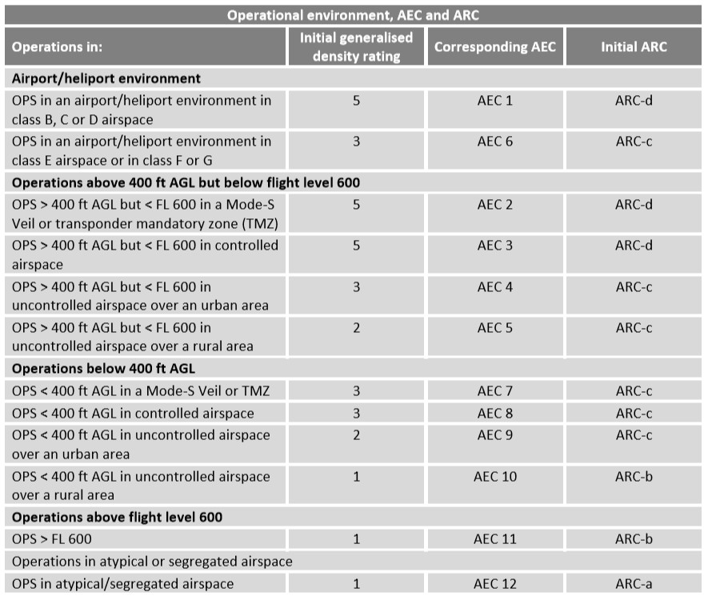
Image 29:Initial ARC Assignment (SORA EU 2019/947)

3.4.3.2 Lowering the Initial ARC
The reduction of initial ARC risk using Figure 28 is justified with the mitigations presented in Section 3.4.3.2.1 Based on the strategic and tactical mitigations, the initial ARC is reduced one level to: Residual ARC: ARC-b
Reduced density rating: AEC 8 & AEC 9
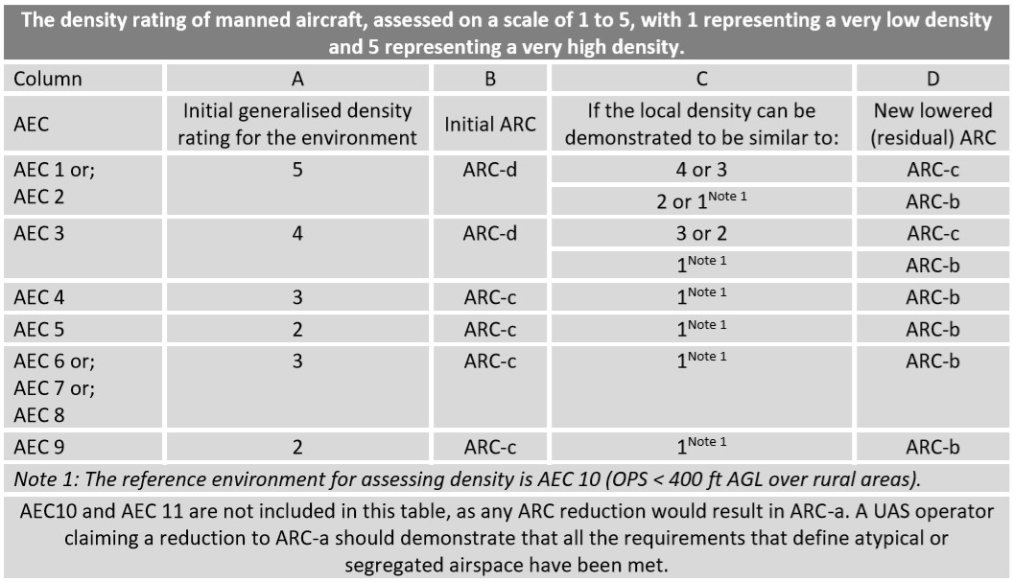
Image 30:Lowering the Initial ARC (SORA EU 2019/947)

3.4.3.3 Strategic Mitigation
The following strategic mitigations are presented to lower the initial ARC.
Operational Restriction
- Geographical Boundary: the routes are planned so that the minimum distance to airports / heliports is at least 1 km when operating in Controlled Airspace.
  - If operating within 1km of an airport or on the grounds of an airport all flights will be controlled by ATC.
- Time Limitations: No mitigation of this type is proposed.
- Time of Exposure: The time of exposure to airport/heliport environments occurs for small time windows of the mission. ATC can have a Time constraint on our Operations once inside Controlled Airspace with approval.
Common Structures and Rules
- The DJI Default flying App DJI Pilot is equipped with electronic cooperative system DAA (Detect And Avoid), and navigation and anti-collision lighting.
- All Drones have Green and Red LEDs front and Back.
- NOTAMS are read during the flight-preparations phase.
- When Operating in Controlled Airspace ATC is contacted during the flight-preparations phase to obtain information about other manned aircraft operating on our area, if operating in high volume of Manned aircraft.
- When Operating in Controlled Airspace ATC is contacted during the pre-flight & the post flight to communicate the beginning and end of the flight operations.
- App Boundary Containment/Geofence limits are used to keep the Drone within the Flight Geographical Zone.
VLOS de-confliction scheme
- ATC will inform pilots if another UAS operator is operating nearby, if any contact details are given Your Company Name Pilot will contact this other operator and de-conflict flights.
- If operating with observer and they identify another UAS or approaching manned aircraft, they will instruct Remote Pilot to land immediately.
  - Action - The operator will initiate a rapid descend if traffic is crossing an alert boundary and operating at less than 1000ft.
  - The observer monitoring traffic uses the phrase: ‘DESCEND!, DESCEND!, DESCEND!’.
- If Remote Pilot identifies or hears another UAS or approaching Manned Aircraft, they will land immediately.
  - Action - The operator will initiate a rapid descend if traffic is crossing an alert boundary and operating at less than 1000ft. while calling out ‘DESCEND!, DESCEND!, DESCEND!’.

3.4.3.4 Tactical Mitigation Performance Requirement - TMPR
Tactical mitigations are those applied after take-off to reduce the rate of collision by modifying the geometry and/or dynamics if the aircraft in conflict based on real-time aircraft conflict information. A Tactical Mitigation could be a piece of hardware installed in the aircraft.
For this operation, the following tactical mitigations are proposed:
- DAA: based on a combination of ground-based and air-based system with pilot actions.
- All flights are VLOS this is a considered to be an acceptable tactical mitigation for collision risk for all ARC levels.

3.4.3.5 TMPR Qualitative Requirement
TMPR qualitative requirement from both ARC-b and ARC-c are satisfied:
Point to Note: Originally the regulations for ‘see and avoid’ and ‘avoid collisions’, assumed that a pilot was on board the aircraft. With a UAS, this assumption is no longer valid, as the aircraft is piloted remotely. Under VLOS, the pilot/UAS operator accomplishes ‘see and avoid’ by keeping the UAS within their VLOS. The UAS remains close enough to the remote pilot/observer to allow them to see and avoid another aircraft with human vision unaided by any device other than, perhaps, corrective lenses. VLOS is generally considered an acceptable means of compliance with the ‘remain well clear from’ and ‘avoiding collisions’. VLOS generally provides sufficient mitigation for cases where the requirements for tactical mitigations are low, medium, and high.
TMPR qualitative criterion table
Detect:
The air traffic detection system should detect 70% of the manned aircraft in the detection volume 15km away of the UAS.
The pilot is aware of the air traffic via the DAA and other web-based real time aircraft tracking systems.
The Use of Flight Radar 24 App is an additional onsite web-based app in which the Remote Pilot or Observer can use for the notification of Manned aircrafts.
Based on the above: Low
Decide:
The RP is trained to execute evasive commands as shown in the abnormal and emergency procedures.
If Remote Pilot identifies or hears another UAS or approaching Manned Aircraft, they will land immediately.
- Action - The operator will initiate a rapid descend if traffic is crossing an alert boundary and operating at less than 1000ft. while calling out ‘DESCEND!, DESCEND!, DESCEND!’.
Based on the above: Low
Command:
The primary LTE C2 link does not exceed the latency threshold of 3 seconds.
Based on the above: Low
Execute:
The following commands can be executed depending on the nature of the situation:
- Hold the mission loitering about a point.
- UAS descending to an altitude not higher than the nearest trees, buildings, or infrastructure or ≤ 60 feet AGL.
- Hold and descent / ascent to a ‘safe altitude’ in less than 1 min.
- Go-To a different location.
- Land on the spot. (Direct landing feature)
- Activate Return to Home Function.
These Actions can be carried out for Multi-Rotor Drones.
Based on the above: Low
Feedback Loop:
The DAA system should have the following characteristics:
- The refreshing rate of the system is around the one second.
- The latency of the system is normally around 3 seconds. This is however dependent on the mobile phone network.
- The system should detect 90% of the manned aircraft in the detection volume.
- The range of detectability should reach at least the 15km.

Note: the statements above referring to the feedback loop are neither proven nor documented by the system provider and have been tested in the field.
Based on the above: Low

3.4.3.6 TMPR robustness (integrity and assurance) assignment
TMPR robustness (integrity and assurance) assignment.
Level of Integrity:
It is expected that the loss of function of the performance of the tactical mitigation system lies between the 1E-2 and the 1E-3. There is no quantitative analysis to sustain the statement above, but it is based on 4 years of VLOS experience
Based on the above:
Level of integrity: Low
Level of assurance:
Your Company Name has already used this DAA system once in the past, being able to detect more than 70% of the manned aircraft and avoid collisions with manned aircraft. Your Company Name also use a third-party app in conjunction with the DAA system. The third-party app is ‘Flightradar24’
Based on the above:
Level of assurance: Low
Based on the above, the overall level of Robustness is: Low

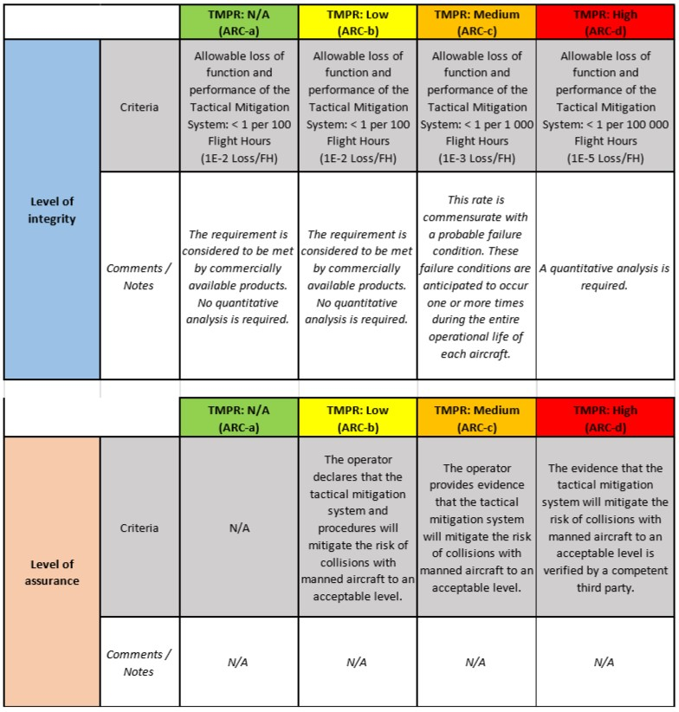

Image 31:TMPR Integrity and Assurance Objectives (SORA EU 2019/947)

3.4.4 SAIL
Using the information provided in Figure 26, with a final GRC = 3 & a residual ARC-b the SAIL is determined as: SAIL = II
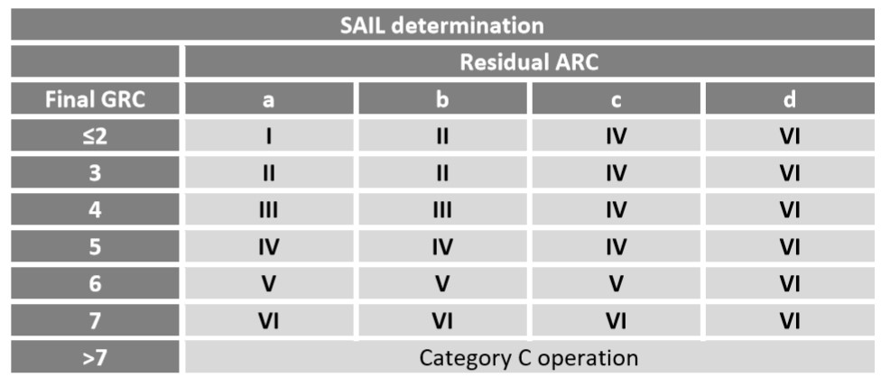
Figure 30:SAIL Determination (SORA EU 2019/947 (Figure 25 Table 4))

3.4.5 OSOs
The Operation Safety Objectives are list below in two tables. There is 24 in total. The SAIL number is a guideline on what presently the mitigation level is. Weather it’s a Low (L), Medium (M), High (H), Optional (O). We will now mitigate as many of these OSO’s to show this operation can be conducted Safely. In some OSO’s if we can achieve the requirement and succeed it we will reflect this in Table 14: summary of OSO Analysis.

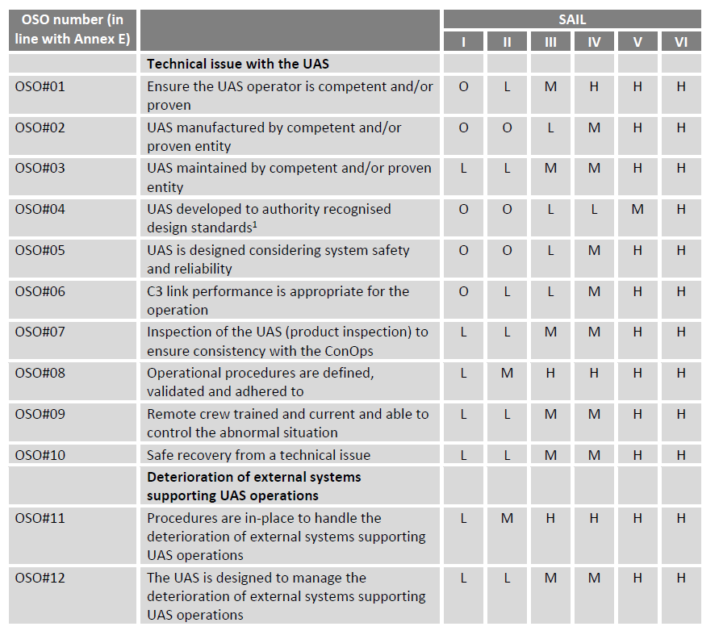

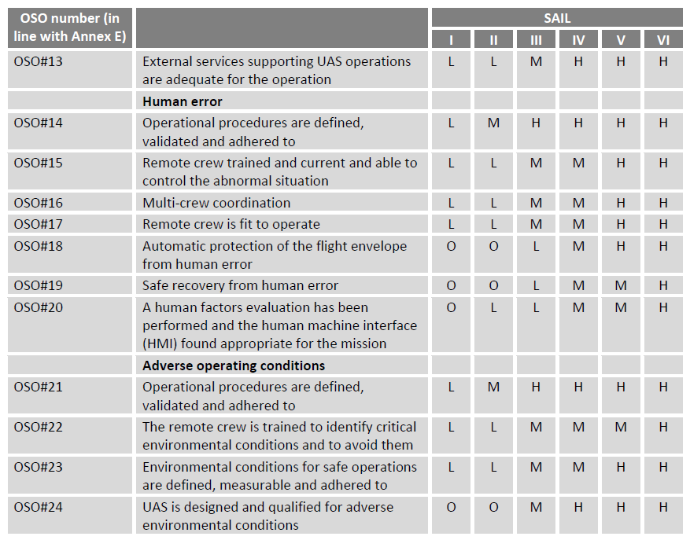

 | Construction Sites
OSO #25 | Operational procedures are defined, validated and adhered to | L | M | H | H | H | H
OSO #26 | The Remote Pilot is trained to identify critical environmental conditions or changes and to avoid them | L | M | H | H | H | H
OSO #27 | Environmental conditions for safe operations are defined, measurable and adhered to | L | L | M | H | H | H
OSO #28 | Flight Geography and ground risk adhered to | L | M | H | H | H | H
OSO #29 | Flight Geography and Air Risk adhered to | L | M | H | H | H | H
 | Quarry Sites
OSO #30 | Flight Geography and ground risk adhered to | L | M | H | H | H | H
OSO #31 | Flight Geography and Air Risk adhered to | L | M | H | H | H | H
OSO #32 | The Remote Pilot is trained to identify critical changes to environmental conditions, Dust Clouds, Blast areas | L | M | H | H | H | H

OSO | Integrity | Assurance | Robustness | Objective | Satisfied | Comments
Insert O,L,M or H under the correct heading |  |  |  |  | Y/N | Add comments if need be.
1 | - | - | - | L
2 | - | - | - | O |  | The EASA has defined manufacturing standards to comply with but not to be implemented until Jan 2023
3 | - | - | - | L
4 | - | - | - | O |  | The EASA has defined manufacturing standards to comply with but not to be implemented until Jan 2023
5 | - | - | - | O
6 | - | - | - | L |  | The supporting evidence is in progress
7 | - | - | - | L
8 | - | - | - | M |  | Human error can still lead to accidents,
9 | - | - | - | L
10 | - | - | - | L |  | Integrity and assurance levels are met due to the experience and training of Pilots.
11 | - | - | - | M |  | Human error can still lead to accidents,
12 | - | - | - | L |  | Integrity and assurance levels are met due to the experience and training of Pilots.
13 | - | - | - | L
14 | - | - | - | M |  | Human error can still lead to accidents,
15 | - | - | - | L
16 | - | - | - | L
17 | - | - | - | L
18 | - | - | - | O
19 | - | - | - | O
20 | - | - | - | L
21 | - | - | - | M |  | Human error can still lead to accidents,
22 | - | - | - | L
23 | - | - | - | L
24 | - | - | - | O
25 | - | - | - | M
26 | - | - | - | M
27 | - | - | - | L
28 | - | - | - | M
29 | - | - | - | M
30 | - | - | - | M
31 | - | - | - | M
32 | - | - | - | M
Point to Note: a change in color in Objective column means Overall Level Of Robustness has been superseded.
Table 10: Summary of the OSO Analysis

.4.6.1 OSO1
Category: Technical issue with the UAS OSO01
Topic: Ensure the UAS operator is competent and/or proven

Level of Integrity:
- Your Company Name is truly knowledgeable of the UAS being used.
- There are relevant operational procedures in place (see Section 4.1)
  - Checklists
  - Maintenance
  - Training
  - Responsible
  - Associated duties
- There is a method to identify and assess the risk associated to the operation, based on the design of the operation made by the FOM and the flight preparations risk management sated. Based on the above:
Level of integrity OSO01: Medium

Level of assurance:
- The elements detailed in the level of integrity are addressed in this ConOPS. Based on the above:
Level of assurance for OSO01: Low
Based on the above, the over all level of Robustness for OSO01 is: Low

3.4.6.2 OSO02
Category: Technical issue with the UAS OSO02
Topic: UAS manufactured by competent and/or proven entity

Level of Integrity:
DJI manufacturing procedures cover:
Specification of materials, suitability and durability of the materials, and the processes necessary to allow for repeatability in manufacturing, and conformity within acceptable tolerances
Level of integrity OSO02: Low

Level of assurance:
EASA have published Manufacturer’s requirements for different types of CE marking requirements under EU Delegated Regulation 2019/945. The CE marking of Drones will not happen until Jan 2023. Based on the above:
Level of assurance for OSO02: Low
Based on the above, the over all level of Robustness for OSO02 is: Low

3.4.6.3 OSO03
Category: Technical issue with the UAS OSO03
Topic: UAS maintained by competent and/or proven entity

Level of Integrity:
Your Company Name complies with:
The maintenance staff is competent and has been authorized by [Company] to conduct Visual inspections and small Maintenance on the UAS. The maintenance staff uses the UAS maintenance instructions while performing maintenance. Scheduled maintenance of each UAS is organized and in accordance with a maintenance program see Section 2.6 The maintenance log is used to record all the maintenance conducted on the UAS including releases. Based on the above:
Level of integrity OSO03: Low

Level of assurance: This Assurance has two Criterion 1. Procedure & 2. Training

Criterion 1. Procedure:
- The maintenance instructions are documented, see AMM in Table 4.
- The maintenance conducted on the UAS is recorded in a maintenance log system.
A list of the maintenance staff authorized to conduct maintenance is established and kept up to date Section 2.6

Criterion 2. Training:
A record of all the relevant qualifications, experience and/or training completed by the maintenance staff is established and kept up to date Section 2.5.
Based on the level of assurances of both Criterions above:
Level of assurance for OSO03: Low
Based on the above, the over all level of Robustness for OSO03 is: Low

3.4.6.4 OSO04
Category: Technical issue with the UAS OSO04
Topic: UAS developed to authority recognized design standards

Level of Integrity:
The EASA have release Design Standards for Drones to Operate in the European Union but have allowed time for Drone Manufacturers to have these Design Standards in place in the form of a CE Marking. The timeline is January 1st 2023. At present no requirement from EASA to implement the Design Standards. Based on the above:
Level of integrity OSO04: Low

Level of assurance:
EASA have published Manufacturer’s requirements for different types of CE marking requirements under EU Delegated Regulation 2019/945. The CE marking of Drones will not happen until Jan 2023. Based on the above:
Level of assurance for OSO04: Low
Based on the above, the over all level of Robustness for OSO04 is: Low

3.4.6.5 OSO05
Category: Technical issue with the UAS OSO05
Topic: UAS is designed considering system safety and reliability

Level of Integrity:
Upward, Downward and Sideward Avoidance Sensors with audible tones to warn pilot of close objects. Low battery warnings and Critical battery warnings with audible tones to warn pilot of error. At low battery warning the aircraft is designed to active the “Return to Home function”. The Software allows the pilot to create a Geo-Fence Boundary Box that maintains the drone inside it. This feature can be changed according to Mission Parameters and from mission to mission. Based on the above:
Level of integrity OSO05: Medium

Level of assurance:
The safety aspects of these aircraft are very similar as they are manufactured by the same organisation. The equipment, systems, and installations are designed to minimise hazards by the manufacturer. The Safety features have been tested and all Pilots are fully trained on how to recognises these Issues and respond correctly. The training that is required is covered under the Emergency procedures of the Internal Drone training course. This is recorded and all students receive a Course completion on successfully passing the course. Based on the above:
Level of assurance for OSO05: Medium
Based on the above, the over all level of Robustness for OSO05 is: Medium

3.4.6.6 OSO06
Category: Technical issue with the UAS OSO06
Topic: C3 link performance is appropriate for the operation

Level of Integrity:
Your Company Name states that the performance, RF spectrum usage and environmental conditions for C3 links are adequate to safely conduct the intended operation, and The systems of the UAS use mechanism to protect itself against interferences. The RP has the means to continuously monitor the C3 performance and ensures that the performance continues to meet the operational requirements.
Level of integrity OSO06: Low

Level of assurance:
The LTE telemetry link quality is shown to the Remote Pilot in the Drone live view on tablet/Phone/Laptop. The RC signal strength is shown under the Signal Strength in the Live App. [Company] declares that this level of integrity has been achieved. Based on the above:
Level of assurance for OSO06: Low
Based on the above, the over all level of Robustness for OSO06 is: Low

3.4.6.7 OSO07
Category: Technical issue with the UAS OSO07
Topic: Inspection of the UAS (product inspection) to ensure consistency with the ConOps

Level of Integrity:
The remote crew ensures that the UAS is in a condition for safe operation and conforms to the approved ConOps. The level of integrity is defined by the level of assurance Based on the above:
The distinction between a low, a medium and a high level of robustness for this criterion is achieved through the level of assurance
Level of integrity OSO07: Medium

Level of assurance: This Assurance has two Criterion 1. Procedure & 2. Training

Criterion 1. Procedure:
Product inspection is documented in the Flight log and accounts for the manufacturer’s recommendations if available.
The product inspection is documented using checklists, see Appendix A.

Criterion 2. Training:
A training syllabus including a product inspection procedure is available, see Section 3.7. The UAS operator provides competency-based, theoretical, and practical training. This initial training is conducted through a Recognised Entity approved by the IAA. All staff members that are trained under the Specific Category will have to successfully complete a flight exam by this DUTO. Flight Exam certificate will be awarded to the Staff member.
Based on the level of assurances of both Criterions above:
Level of assurance for OSO07: Medium
Based on the above, the over all level of Robustness for OSO07 is: Medium

3.4.6.8 OSO08
OSO 08 covers also OSOs: 11, 14 and 21.
Category: Technical issue with the UAS OSO08
Topic: Operational procedures are defined, validated, & adhered to

Level of Integrity: This Integrity has three Criterion’s 1. Procedure Definition, 2. Procedure Complexity & Consideration of Potential Human Error

Criterion 1. Procedure Definition:
Operational procedures appropriate for the proposed operation are defined and, as a minimum, cover the following elements:
- Flight planning.
- Pre- and post-flight inspections see Section 4.1
- Procedures to evaluate the environmental conditions before and during the mission (i.e., real-time evaluation).
- Procedures to cope with unexpected adverse operating conditions see Section 7
- Normal procedures see Section 4.
- Contingency procedures (to cope with abnormal situations see Section 5).
- Emergency procedures (to cope with emergency situations see Section 6).
- Occurrence reporting procedures see Section 10; and
The limitations of the external systems supporting UAS operation are defined in the Operations Manual.

Criterion 2. Procedure Complexity:
VLOS contingency and emergency procedures do not require manual control of the RP, but the activation of commands. The operational procedures are designed seeking simplicity and safety.

Criterion 3. Consideration of Potential Human Error:
The operation is designed to be conducted by the minimum number of crew members, among which the distribution and assignment of tasks, and An internal checklist ensures the crew are adequately performing their assigned tasks.
The procedures take human error in consideration, by means of:
- 4 eye check during mission planning.
- Use of checklists during the different flight phases.
- Practice of abnormal and emergency situations.
- Aeronautical decision making is included in the training syllabus.
The training and procedures are designed so that the RP works together with the rest of the crew reducing errors, avoiding stress, and increasing efficiency. However, Human error can still lead to accidents, and the crew does not receive specific crew resource management (CRM) Training in identifying Human Traits is covered in the theorical knowledge course all staff members for the Specific Category attend.
Level of integrity OSO08: High

Level of assurance:
The operational procedures have been designed, improved, and validated based on [Company] experience of VLOS operations. Accumulation of approx. 100hours by all Sub-Entities. The adequacy of the contingency and emergency procedures is proven though dedicated flight Missions, Training flights & testing.
The flight tests performed to validate the procedures and checklists cover the complete flight envelope. The procedures, checklists, flight tests and simulations are validated by a competent third party.
Based on the level of assurances of both Criterions above:
Level of assurance for OSO08: Medium
Based on the above, the over all level of Robustness for OSO08 is: Medium

3.4.6.9 OSO09
OSO 09 covers also OSOs: 15, and 22.
Category: Technical issue with the UAS OSO09
Topic: Remote crew trained and current and able to control the abnormal situation

Level of Integrity:
The RPs involved in the operation have competency-based, theoretical, and practical training adequate for the operation covering:
- the UAS regulation. (i) Data Protection
- airspace operating principles. (j) UAS Performance
- airmanship and aviation safety; (k)Technical & Operational Mitigations for Air risks
- human performance limitations. (l)Technical &Ops Mitigations for Ground risks
- meteorology. (m) SORA & PDRA – STS-01
- navigation/charts.
- operating procedures.
- Flight Exam by IAA Examiner
The distinction between a low, a medium and a high level of robustness for this criterion is achieved through the level of assurance
Level of integrity OSO09: High

Level of assurance:
- Point (h) of the items exposed above, is included in the syllabus of the theoretical and practical training of [Company], see Section 2.6.
- The training syllabus of [Company] and the crew competencies are verified by a competent third party, Survey Drones Ireland who are a Recognised Entity (DUTO)
- Points (a) through (m) are covered in the syllabus of a certified ground and flight training where the pilots obtain their Remote Pilot Licence.
Based on the above:
Level of assurance for OSO09: High
Based on the above, the over all level of Robustness for OSO09 is: High

3.4.6.10 OSO10
Category: Technical issue with the UAS OSO10
Topic: Safe recovery from a technical issue

Level of Integrity:
- It cannot be expected that when operating overpopulated areas or assemblies of people a fatality will not occur from any probable failure of the UAS or any external system supporting the operation, however:
- the operation does take place over populated areas but not over assemblies of people, and As shown in Section 3, even under the event of crash the chances of single fatalities are low and the risk is acceptable.
- All pilots are trained to select ELZ on all missions at the Flight Planning stage, they will also Identify them when on site, & continuously update them as the Drone moves through its flight mission.
- All Pilots are trained on Emergency procedures and have a course completion certificate to state this. This training is part of the Internal Flight Training course. Based on the above:
Level of integrity OSO10: Low

Level of assurance:
- The design and installation features met and satisfy the low integrity criterion.
- Risks to the CONOPs are considered: e.g., weather limitations.
Based on the above:
Level of assurance for OSO10: Low
Based on the above, the over all level of Robustness for OSO10 is: Low

3.4.6.11. OSO11
Category: Deterioration of external systems supporting UAS operations
Topic: Procedures are in-place to handle the deterioration of external systems supporting UAS operations
Covered with OSO08.

3.4.6.12 OSO12
Category: Deterioration of external systems supporting UAS operations
Topic: The UAS is designed to manage the deterioration of external systems supporting UAS operations
Covered with OSO10.

3.4.6.13 OSO13
Category: Deterioration of external systems supporting UAS operations OSO13
Topic: Safe recovery from a technical issue

Level of Integrity:
[Company] ensures that the level of performance for any externally provided service necessary for the safety of the flight is adequate for the intended operation.
Based on the above:
Level of integrity OSO13: Low

Level of assurance:
[Company] declares that the requested level of performance for any externally provided service necessary for the safety of the flight is achieved (without evidence being necessarily available)(Drone Policy outlining external services)
Based on the above:
Level of assurance for OSO13: Low
Based on the above, the over all level of Robustness for OSO13 is: Low

3.4.6.14 OSO14
Category: Human Error
Topic: Operational procedures are defined, validated, and adhered to
Covered with OSO08.

3.4.6.15 OSO15
Category: Human Error
Topic: Remote crew trained and current and able to control the abnormal situation
Covered with OSO09

3.4.6.16 OSO16
Category: Human Error OSO16
Topic: Multi-crew coordination

Level of Integrity: This Integrity has three Criterion’s 1. Procedure, 2. Training & 3. Communication on Devices

Criterion 1. Procedure:
Procedures to ensure coordination between the crew members and robust and effective communication channels are available and at a minimum cover:
(a) assignment of tasks to the crew and
(b) establishment of step-by-step communications

Criterion 2. Training:
The crew training covers the coordination between different crew members in terms of communications, roles, and responsibilities, see Section 3.7.

Criterion 3. Communication on Devices:
N/A
Level of integrity OSO16: Low

Level of assurance: This Assurance has three Criterion’s 1. Procedure, 2. Training & 3. Communication on Devices:

Criterion 1. Procedure:
The procedures are defined according to the EASA standards (EU) 2019/947.
The adequacy of the procedures has been proven though by training and VLOS mission operations have an accumulation of approx. 100hours by all Sub-Entities.

Criterion 2. Training:
The training syllabus is available in Section 3.7.
A DUTO Recognised Entity provides this training competency-based, theoretical, and practical training.

Criterion 3. Communication on Devices:
N/A
Based on the level of assurances of the Criterions above:
Level of assurance for OSO16: Low
Based on the above, the over all level of Robustness for OSO16 is: Low

3.4.6.17 OSO17
Category: Human Error OSO17
Topic: Remote crew is fit to operate

Level of Integrity:
[Company] has a policy defining how the crew can declare themselves fit to operate before conducting any operation, see 3.4.2 and 3.4.3 in OM.
- The duty and resting times are defined an adequate for the operation.
The fitness of the crew members (IMSAFE) is checked during the flight preparations. Based on the above, the level of integrity is
Level of integrity OSO17: Medium

Level of assurance:
- The crew duty, flight duty and the resting times policy are documented.
- The crew duty cycles are logged and cover at a minimum.
However,
- no evidence is registered that the crew is fit to operate.
Based on the above, the Level of Assurance:
Level of assurance for OSO17: Medium
Based on the above, the over all level of Robustness for OSO17 is: Low

3.4.6.18 OSO18
Category: Human Error OSO18
Topic: Automatic protection of the flight envelope from human error

Level of Integrity:
DJI Flight control system incorporates automatic protection of the flight envelope to prevent the remote pilot from making any single input under normal operating conditions that would cause the UAS to exceed its flight envelope or prevent it from recovering in a timely fashion. Based on the above:
Level of integrity OSO18: Low

Level of assurance:
The automatic protection of the flight envelope has been developed out of the box (e.g.using commercial off-the-shelf elements), without following specific standards. DJI Flight Apps will be used across all UAS of Your Company Name The competent authority may request EASA to validate the claimed integrity.
Based on the above:
Level of assurance for OSO18: Low
Based on the above, the over all level of Robustness for OSO18 is: Low

3.4.6.19 OSO19
Category: Human Error OSO19
Topic: Multi-crew coordination

Level of Integrity: This Integrity has three Criterion’s 1. Procedure, 2. Training & 3. Communication on Devices

Criterion 1. Procedures and Checklist:
Procedures and checklists that mitigate the risk of potential human errors from any person involved with the mission are defined.

Criterion 2. Training:
The crew is trained to use checklists and procedures, however the training does not include a specific CRM currently but is design to ensure safe and efficient operations.

Criterion 3. UAS Design:
DJI systems detecting and/or recovering from human errors are developed according to industry best practices.
Level of integrity OSO19: Low

Level of assurance: This Assurance has three Criterion’s 1. Procedures and Checklist, 2. Training & 3. UAS Design:

Criterion 1. Procedure and Checklist:
The procedures are defined according to the EASA standards (EU) 2019/947.
The adequacy of the procedures has been proven though by training and VLOS mission operations have an accumulation of approx. 100hours by all Sub-Entities.
Dedicated flight test is put in place to validate the procedures.

Criterion 2. Training:
This level of assurance is based on the level of assurance of OSOs 9, 15 and 22.

Criterion 3. UAS Design:
[Company] declares that the required level of integrity has been acquired. [Company] do not design Drones. All [Company] drones are from a Competent UAS manufacturer
Based on the level of assurances of the Criterions above:
Level of assurance for OSO19: Low
Based on the above, the over all level of Robustness for OSO19 is: Low

3.4.6.20 OSO20
Category: Human Error OSO20
Topic: A human factors evaluation has been performed and the human machine interface (HMI) found appropriate for the mission

Level of Integrity:
The UAS information and control interfaces are clearly and succinctly presented and do not confuse, cause unreasonable fatigue, or contribute to remote crew errors that could adversely affect the safety of the operation. Based on the above:
Level of integrity OSO20: Low

Level of assurance:
[Company] has designed the procedures and training to improve the HMI experience of the crew, increasing the situation awareness of the crew and improving the aeronautical decision making.
Based on the above:
Level of assurance for OSO20: Low
Based on the above, the over all level of Robustness for OSO20 is: Low

3.4.5.21 OSO21
Category: Adverse operating conditions
Topic: Operational procedures are defined, validated, and adhered to.
Covered with OSO08.

3.4.5.22 OSO22
Category: Adverse operating conditions
Topic: The remote crew is trained to identify critical environmental conditions & to avoid them.
Covered with OSO09

3.4.6.23 OSO23
Category: Adverse operating conditions OSO23
Topic: Environmental conditions for safe operations are defined, measurable and adhered to

Level of Integrity: This Integrity has three Criterion’s 1. Definition, 2. Procedures 3. Training

Criterion 1. Definition:
The environmental conditions for safe operations are defined in this operations manual.

Criterion 2. Procedures:
Procedures to evaluate environmental conditions before and during the mission (i.e., real-time evaluation) are available and include assessment of meteorological conditions with a simple recording system.

Criterion 3. Training:
The training covers the assessment of meteorological conditions.
Level of integrity OSO23: Medium

Level of assurance: This Assurance has three Criterion’s 1. Definition, 2. Procedures 3. Training:

Criterion 1. Definition:
[Company] can provide support of this evidence beyond the information stated in this operations manual.

Criterion 2. Procedures:
The procedures are validated by standard means of compliance of the competent authority.
Dedicated flight test is put in place to validate the procedures.

Criterion 3. Training:
The training syllabus is available in Section 3.7.
DUTO Provides competency-based, theoretical, and practical training.
Based on the level of assurances of the Criterions above:
Level of assurance for OSO23: Medium
Based on the above, the over all level of Robustness for OSO23 is: Medium

3.4.6.24 OSO24
Category: Adverse operating conditions OSO24
Topic: UAS is designed and qualified for adverse environmental conditions

Level of Integrity:
The UAS designed to limit the effect of environmental conditions stated in Section 3.
Based on the above:
Level of integrity OSO24: Medium

Level of assurance:
The adequacy of the procedures has been proven though by training and VLOS mission operations have an accumulation of approx. 100hours by all Sub-Entities Based on the above:
Level of assurance for OSO24: Medium
Based on the above, the over all level of Robustness for OSO24 is: Medium

3.4.6.25 OSO25
Category: Construction sites
Topic: Operational procedures are defined, validated and adhered to
Covered with OSO08.

3.4.6.26 OSO26
Category: Construction sites
Topic: The Remote Pilot is trained to identify critical environmental conditions or changes and to avoid them
Covered with OSO09.

3.4.6.27 OSO27
Category: Construction sites
Topic: Environmental conditions for safe operations are defined, measurable & adhered to
Covered with OSO23

3.4.6.28 OSO28
Category: Construction sites OSO28
Topic: Flight Geography and ground risk adhered to

Level of Integrity:
The Flight Geography area is the Construction Site whole. This is a controlled environment with safety heavily adhered to. The Drone has a geofence capability to keep the drone in a boundary box. The Distance and height can be inputted into the Flight app and the Drone will not leave this boundary box, once GPS is functioning. See Section 3.1.3.4. All Involved/Uninvolved person wear Personal Protective equipment. Hard Hats, Hi-vis vest, long sleeves gloves and Eye goggles. On terminating the flight the drone will not cause injury to persons because of the PPE on all Persons.
Based on the above:
Level of integrity OSO28: Medium

Level of assurance:
All Personal must attend a induction prior to entering a construction site this outlines what they can and cant do. If they fail to follow these rules they will be asked to leave site. There is a record of their induction. If a hard hat is removed from a persons while on site they will be asked to leave site. It is a policed environment therefore the injury to persons is greatly reduced.
Based on the above:
Level of assurance for OSO28 Medium
Based on the above, the over all level of Robustness for OSO28 is: Medium

3.4.6.29 OSO29
Category: Construction sites OSO29
Topic: Flight Geography and Air Risk adhered to

Level of Integrity:
The Flight Geography area is the Construction Site whole. This is a controlled environment with safety heavily adhered to. The Drone has a geofence capability to keep the drone in a boundary box. The Distance and height can be inputted into the Flight app and the Drone will not leave this boundary box, once GPS is functioning. See Section 3.1.3.4. This Boundary box allows maximum flight height to be inputted. In controlled airspace when operating within 5km of an airport ATC will control RP’s flight height, this shall be inputted into Flight App.
Based on the above:
Level of integrity OSO29: Medium

Level of assurance:
The RP has been trained in how to set up the Boundary Box prior to any flight mission. U.F 101 applications need to submit as part of [Company] Operating procedures.
Based on the above:
Level of assurance for OSO29 Medium
Based on the above, the over all level of Robustness for OSO29 is: Medium

3.4.6.30 OSO30
Category: Quarry sites
Topic: Flight Geography and Ground Risk adhered to
Covered with OSO28

3.4.6.31 OSO31
Category: Quarry sites
Topic: Flight Geography and Air Risk adhered to
Covered with OSO29

3.4.6.32 OSO32
Category: Quarry sites OSO32
Topic: The Remote Pilot is trained to identify critical changes to environmental conditions, Dust Clouds, Blast areas

Level of Integrity:
The Flight Geography area is the Construction Site whole. This is a controlled environment with safety heavily adhered to. The Drone has a geofence capability to keep the drone in a boundary box. The Distance and height can be inputted into the Flight app and the Drone will not leave this boundary box, once GPS is functioning. See Section 3.1.3.4. This Boundary box allows maximum flight height to be inputted. In controlled airspace when operating within 5km of an airport ATC will control RP’s flight height, this shall be inputted into Flight App.
Based on the above:
Level of integrity OSO32: Medium

Level of assurance:
The RP Flight training is recorded in the Organisation personal file. This is is reviewed every 6 months when internal training happens for all RP’s
Based on the above:
Level of assurance for OSO32 Medium
Based on the above, the over all level of Robustness for OSO32 is: Medium

3.5 Technical means used.
These sections will outline main characteristics, performance, and limitations, including UAS, external systems supporting the UAS operation, facilities All your UAS to be added Here.

3.5.1 Multi-Rotor DJI Mavic 2 Enterprise Advanced
DJI Mavic 2 Enterprise Advanced
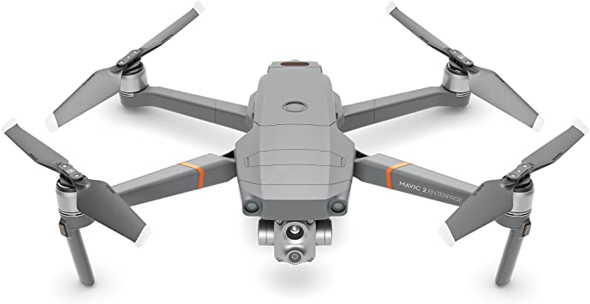
Image 27:Mavic 2 Enterprise Advanced
The Aircraft
The composite of the aircraft is a mix of Plastic and Carbon Fibre. It is a durable and robust airframe. It has a diagonal span of 350mm. The Maximum take-off weight is 907g. It can fly at slow speeds Manually and in Semi-Autonomous mode, e.g., Flight plan mapping missions. It has the ability to terminate flight at any given time by the RP.
The Main Characters of the Mavic 2 Enterprise Advanced
Weight | 909grams – MTOW 1100G
Diagonal Wheelbase | 354mm
Max Ascent Speed | P-mode: 5m/s  S – Mode: 6m/s
Max flight Speed | P-mode: 14m/s  S-mode: 20m/s
Max Wind Speed Resistance | 10m/s
Max Service Ceiling Above Sea Level | 19685 feet (6000 m)
Max Flight Time | Approx. 28mins
Operating Temperature Range | 20° to 50°C
Ingress Protection Rating | NO IP rating
Satellite Positioning Systems | GPS+GLONASS+BeiDou+Galileo
Infrared Sensing System
Infrared Sensing System Distance | 0.6 – 23feet (0.2 – 7meters)
Operating Environment | reflectivity >8%
Camera
RGB Sensor | 1/2” CMOS, Effective Pixels: 48 M
Gimbal | 3 Axis Stabilisation system
Thermal Sensors | Uncooled VOx Microbolometer
Remote Controller
Max Transmission Distance | 7km - 2.4 GHz - 5.8GHz
Transmitter Power (EIRP) | 2.4 GHz FHSS link (106 to 63 mW)
Operating Current/Voltage | 3850 mAh weight 297g
See Manufacturers User Manual for further information. This User Manual is part of our additional documentation and we have it recorded as such in our list of references table. Please see section 1.2.2 List of Refence Documents

3.6 Competency, Duties and Responsibilities

Role | Name | Contact
Head of Drone Operations
Safety Manager
Head of Training | External Company
Maintenance Manger
Remote Pilot/Chief
Remote Pilot
Visual Observer (VO)
Remote Pilot
Remote Pilot
Table 11: List of Pilots

3.6.1 Head of Drone Operations.
The Head of Drone Operations is a highly responsible role. Which will be included and be not limited to the following. They must be trained under the current Drone regulations for Drone Operations within the Land of Ireland. They may not hold a Drone Licence, if they wish not to, but have the relevant courses completed. This will ensure they fully understand what is required from holding this role. They can apply for a Drone Licence if they wish to do so.

The qualifications required for this role are as follows.
- Must be Registered within the MySRS Portal as a key person under “Responsible Manager” for Your Company Name.
- A1/A3 Proof of online training completed on MySRS Portal.
- A2 Remote Pilot Competency Certificate
- STS-01/PDRA-01 under the Specific Category

The role and responsibilities for this appointment within Your Company Name.
- Responsible authority who must ensure all internal procedures are followed in line with process descriptions, laws, and safety management system.
- Ensuring all departments have enough resources to perform their works.
- Focal point to the management board.
- Responsible for Ireland & UK flight operations.
- Coordination and communication with training organisation, maintenance organisation and project management.
- Ensuring personnel is trained and qualified for intended operations.
- Design and maintenance of Operations Manuals and CONOPS.
- Elaboration and approval of risk assessments.
- Coordination of Ireland & UK operations.
- Focal point for Flight Crew
- Design and Validation of flight routes and operational procedures.
- Communications with the department of civil aviation: submission of documentation and procurement of approvals.

3.6.2 Safety Manager
The Role of Safety Manager is one of importance, they must have a health and safety background. They must understand the current Drone Rules and Regulations with regards to the Air and Ground Risk that is involved in Drone Operations. They may not need to undergo any external Drone Courses, as the Head of training, can explain what is required from the Air and Ground Risk for Drone Operations. The Head of Training can engage with the Safety Manager on the drafting up of any new Risk based documentation to ensure the correct approach is given for Drone Operations. The Safety Manager will oversee all Health and Safety aspects of any Drone operations within Ireland and the UK for Your Company Name.

The qualifications required for this role are as follows
- Must be registered with the IAA MySRS Portal as a Key Person “UAS – Safety Manager” for Your Company Name.
- A1/A3 Proof of online training completed on MySRS Portal.
- Received some training from the Head of training regarding Air and Ground Risk under the current Rules and Regulations for Drone Operations within Ireland & the UK.

The role and responsibilities for this appointment within Your Company Name.
- Facilitate hazard identification, risk analysis and risk management.
- Monitor implementation of risk mitigations and provide periodic reports.
- Designing and maintaining safety management system including organisational handbooks and ensuring safety management trainings.
- Occurrence investigation initiation and follow-up.
- Coordination and communication with authorities regarding incident/accident investigations.

3.6.3 Head of Training
This Role can be held by the same person who is also the Chief Remote Pilot. The type of training they can conduct will be company workflows and flight training on company aircrafts. They cannot certify anyone for Drone Ground School or conduct any Flight Exams. This can only be performed by an IAA Recognised Entity. This person should touch base with the Recognised Entity at least twice a year asking for any changes on Drone Rules and Regulations.

The qualifications required for this role are as follows.
- Must be Registered within the MySRS Portal as a key person under “UAS – Responsible Person/Nominated Person – Flight Operations” for Your Company Name.
- A1/A3 Proof of online training completed on MySRS Portal.
- A2 Remote Pilot Competency Certificate
- STS-01/PDRA-01 VLOS Operations under the Specific Category
- STS-02/PDRA-02 BVLOS Operations under the Specific Category (Optional)

The role and responsibilities for this appointment within Your Company Name.
- Design and maintenance of training standards.
- Organisation of trainings for flight crew and maintenance crew.
- Organisation and qualifications of internal and external trainers and partners.
- Performing trainings (basic, advanced, BVLOS…).
- Design and maintenance of training organisation handbook.
- Monitoring compliance with terms of approval / privileges, risk assessment and mitigations, manuals and procedures, training standards.
- Perform internal audits.
- Consulting operational, trainings, maintenance, and safety department with regards to regulations and regulatory requirements.
- Monitoring compliance with applicable regulations (operational, technical…)

3.6.4 Maintenance Manger
This Role can be held by the same person who is also the Chief Remote Pilot. The Maintenance Manger must know and understand all features of the company’s Drones. They must have read all Manufacturers Manuals/Instructions on the Company’s Drones. They must keep a record of any incidents of any changes to the Aircraft. This includes Firmware Versions and Software Versions. They will liaise with the Drone Manufacturers or Country Agents if a Drone must need to be shipped back for repair. They will be the first point of contact in the unlikely event of an incident. In the event of a test flight after repair the Maintenance Manager can either conduct it themselves once they have the minimum of holding an A1/A3 Tab on their Drone Licence or they request the Chief remote pilot to complete the test flight for them under their watchful eye.

The qualifications required for this role are as follows.
- Must be Registered within the MySRS Portal as a key person under “Maintenance Manager” for Your Company Name.
- A1/A3 Proof of online training completed on MySRS Portal.

The role and responsibilities for this appointment within Your Company Name.
- Ensuring all maintenance requirements developed by Manufacturers are followed and coordination with Manufacturers or Country agent for the shipment of Drones in the event of maintenance/repair.
- Ensuring all maintenance tasks are performed on all Companies Drones if support is requested and all maintenance / repair logs are filled.
- Ensuring maintenance personnel is qualified and trained.
- Design and maintenance of maintenance organisation handbook/tables.
- Communication and coordination with internal and external stakeholders with regards to all maintenance aspects.

3.6.5 Remote Pilot/Chief
The Remote Pilot or Chief Remote Pilot have the final say on whether the Drone operation will take place or not, they are entitled to cancel an operation if he/she is not satisfied with the prevailing conditions. The Head of Operations will task and launch the RP/CRP to conduct flight planning for all Drone Operations. The Chief Remote pilot will then task each Remote Pilot to a project. The Remote Pilot will report back once this is completed and await further taskings from the CRP.
The qualifications required for this role are as follows.
- Must be Registered within the MySRS Portal as a key person under “UAS Responsible Person” for Your Company Name.
- A1/A3 Proof of online training completed on MySRS Portal.
- A2 Remote Pilot Competency Certificate
- STS-01/PDRA-01 under the Specific Category
- STS-02/PDRA-02 BVLOS Operations under the Specific Category (Optional)

The role and responsibilities for this appointment within Your Company Name.
The Chief Remote Pilot is highest authority on site and is responsible for the execution OR supervision of the implementation of the procedures defined in this OM.

Flight Preparations
- Ensure that all the necessary permissions are current and present.
- Ensure that all the crew members are qualified for their role and type of operation.
- Ensure that the third-party insurance of the UAS is current, present and covers all the residual risks of the operation.
- Flight plan filing.
Pre-Flight
- Ensure that the crew including oneself are fit to fly (IMSAFE).
- Ensure that the operating environment (PAVE) satisfies the declared and authorized operational conditions.
- Conduct a safety briefing/project briefing.
- Ensure that the UAS is fit to fly and complies with the instructions and limitations provided by the manufacturer.
- Ensure that the Remote Controller is properly set up and the emergency equipment is accessible.
- Ensure that any payload carried is properly secured and installed, respecting the limits for the mass and CG of the UAS.
- Ensure that the UAS has enough propulsion energy for the intended operation based on:
(i) the planned operation; and
(ii) the need for extra energy in case of unpredictable events
- Verify that the weather conditions at the time of the start as well as those expected for the entire period of the operation are compatible with those defined in the AOM, OM or CONOPs whatever is more restrictive or applicable.
- Plan of flight missions in QGC according to this OM and the UAS limitations described in the AOM, whatever is more restrictive.
- Validate the BVLOS missions together with the FOM.
- Get familiar with the environment and obstacles through scouting flights and survey.

Flight Execution
- Supervise the operation and coordinate the roles of the other crew members.
- Avoid any risk of collision with any manned aircraft and abort a flight when continuing it may pose a risk to other aircraft, people, animals, environment, or property.

Post-Fight
- Documentation of flight data.
- Debriefing

The Chief Remote Pilot can carry out maximum his role as well as the role of the RP simultaneously.

3.6.6 Remote Pilot
The Remote Pilot is the drone pilot for a project. The RP can work alone, or under the supervision of the CRP. He/she will be ensuring all relevant paperwork is completed such as pilot & UAS hours, battery logs etc. He/she will be ensuring all charging and checks prior to deployment are made this includes.
- Maintenance checks are carried out on the systems
- All batteries are charged and checked
- All ancillaries are checked

The RP is responsible for the following:
Pre-Flight
- Assembly and inspection of the UAS.
- Execution of the hover test.
- Setting up the control unit and disposition of the emergency equipment.
- Uploading the correct mission and flight parameters.
- Initiation of the mission.
- Communications with the VO if present/required.
- Payload handling.
- Charging batteries

Flight Execution
- Monitoring the flight parameters.
- Monitoring of weather conditions.
- Monitoring of air traffic.
- Execution of abnormal and emergency procedures.
- Termination of the mission.
- Communications with the VO if Present/required.

Post-Flight
- Disassembly of the UAS
- Inspection for new damages
- Downloading of log files/Data

3.6.7 Visual Observer (VO - Optional)
The VO is normally an external person that takes part in the operation on the extreme end of VLOS. The VO is trained by the Head of Training or the CRP. They do not need to be a licensed Drone Pilot. But having completed the A1/A3 Open Category will give them a bit of understanding of the Rules and Regulations under the Open Category and what they should be looking out for. As one of the Air Risk factors would be from other Drone users and there is a big portion that operate under the Open Category. There is no role in the IAA MySRS portal for this position. It is one that the company may decide to implement if and when the need to do so should arise. The Training of such a person will be internal as there is no official VO course available yet. A VO is a must for BVLOS Operations.
The qualifications required for this role are as follows.
- A1/A3 Proof of online training completed on MySRS Portal. (Optional)

Once the VO is validated, he/she carries on the following task:
- Clearing the landing area of obstacles, animals, and people.
- Provides the RP with information relative to the UAS.
- Ensures that any payload carried is properly secured and installed.

3.6.8 Competency - Fitness for Duty
All involved in the operation of UASs are required to consider their fitness for duty prior to their participation. The Remote Pilot is entitled to deny participation in the operation to anyone if the Remote Pilot considers he/she is not fit.

Prior to the operation all crew members must go through the following check “IMSAFE”:
- Illness
- Medication
- Stress
- Alcohol
- Fatigue
- Emotional load

If any of the previous may have an impact in the safety of the operation, the Remote Pilot must: Substitute the crew member, OR Assign him to a less relevant role, OR
Cancel the operation. If the Remote Pilot is looking to Cancel an Operation, they first must contact the Chief Remote Pilot and he does not respond the RP can then directly call the Head of the UAS Department to request permission to Cancel Drone Operations.

3.6.9 Competency - Shift & Working Hours
The operation is split into shifts to structure the daily activities and establish routines. The shifts are divided into:
- Flight preparations: activities involving permission requests, flight plan elaboration, mission planning, equipment review…
- Pre-Flight: activities involving assembly and checks of the UAS and CU, as well as fitness of crew members. Weather and prevailing conditions review and briefing.
- Flight Execution: including take-off, cruise, delivery, and landing.
- Post-Flight: activities including debriefing, documentation, and maintenance.

Regarding the allowed working hours, duration of shifts and rest time:
- The maximum number of working hours with flight duty per day is 8 h.
- These hours can be interrupted / paused when the pause is in minimum 90 minutes and the crew member can rest adequately.
- The crew member must rest a minimum of 13 h between duty times.
- Only once (1) in a period of 7 days and if approved by the FOM (Flight Operations Manager) a crew member is permitted to extend the duty time to a maximum of 14h. In that case, the crew rest to be followed is in minimum the duration of the duty time ending.
The duty time starts 60 min before the UAS first take-off and ends 30 min after the UAS last landing of the day. This time is broken up with time being on Duty and Flight hours. The Maximum Flight hours one RP can complete in one day will be 5 hours continuous flying. If the RP feels at any stage during the duty time to rest, they must inform the CRP as a replacement maybe required if RP is operating alone.

3.6.10 Competency - Medication & Wellbeing.
At no stage will a RP be under the influence or part take in the consumption of alcohol, narcotics and drugs, sleep aids and anti-depressants these will impair the decision-making during Drone Operations. A RP must declare prior to taking up Duty weather they have taking any of the above substances.
Medication and vaccinations will be allowed once prescribed by a medical doctor, Your Company Name have the right to request a doctor’s note stating this RP is fit for Drone operations under the prescribed Medication & Vaccination.

Fatigue, Stress and Pressure are real when it comes with Drone operations. If at any stage the RP feels any of the above, they must stop Drone Operations and contact the CRP or the Head of the UAS Department. A RP must not fly a Company Drone while they feel Fatigued, Stressed or Pressured. The RP has the final say whether a Drone Project will take place under their command. They must inform the CRP or the Head of the UAS Department if they are looking to Cancel a Drone Project.

3.7 Training
Training will be broken up into Phases. Each phase the student must complete before moving on to the next phase. It will be up to the Head of the UAS Department to make sure the RP is fully qualified before they can start any Drone Operations.

Phase One.
Registration on the IAA MySRS Portal.
Complete online A1/A3 Open Category Course.
Start Application process for the A2 Open Category Course.
Theoretical Ground School and Written Exam is conducted through a DUTO.
Complete the A2 Open Category Application

Phase Two.
Internal or External Flight Training on Multi-Rotor.
Flight Exam conducted by DUTO.
Apply for PDRA-01/STS-01 for Operational Authorisation.

Phase Three.
Flight Operations under supervision of experienced RP.
Internal Upskill and recurrence training – 6 monthly.

3.8 Risk analysis and methods for reduction of identified risks
The control volume of the UAS during the operation is shown Figure 5. The information is extracted from the EASA SORA analysis. The dimension of the different volumes and buffers is as follows:
- Contingency volume: 300m left and right of the flight path.
- Emergency volume: 300m left and right of the flight path.
- Ground risk buffer: as a general approach follow the 1:1 rule, unless specified otherwise in the risk assessment.
- Air risk buffer: as a general approach follow the 1:1 rule, unless specified otherwise in the risk assessment
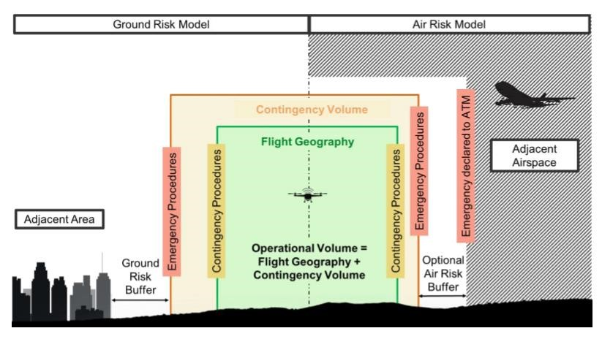
Image 28:Ground Risk / Air Risk Model

3.9 Maintenance
The maintenance scheduled or unscheduled and the repairs are coordinated by the maintenance manager. On site, maintenance is performed by the Maintenance Technician according to the checks defined in Manufacturer’s Instructions Manual. See 1.2.2 List of Refence Documents Every scheduled or unscheduled maintenance work or repair is register in the maintenance log. All internal Maintenance of the Aircrafts will be conducted by the Manufacturers of the Aircraft.

4. Normal procedures.
The standard operation procedures are described using the different flight phases as structure: preparation phase, pre-flight, flight execution and post-flight

4.1 General procedures valid for all operations:
Multi-Rotor Aircraft.
Setup Procedures
- Open Carry Case.
- Take out Drone.
- Visual Inspection of aircraft body for damage.
- Place Drone on the ground.
- Take out Flight Battery.
- Visually inspect this for damage.
- Insert into drone.
- Take out remote controller.
- Visually inspect for damage.

Start-up procedures
- Switch on RC and wait for Software to boot up.
- Switch on Drone and wait for Self-Check conformation tone.
- Activate any unlocking codes if required for site (DJI)
- Confirm Home Position is recorded and correct check it on the Map. (DJI)
- Stand Back and Observe Take-off Area.
- Open flight mission on Table/Phone/Built-in Screen/Computer.
- Check parameters – Edit if need be.
- Upload mission to Aircraft.
- Check Take-off Area for any new hazards.
- Prior to take-off observe Zero Meters in Altitude (+/- 0.9m).
- Start Mission.
- Observe Present Telemetry on Table/Phone/Built-in Screen/Computer.
- Observe Drone at take-off for approx.10meters in Altitude then observe between Telemetry and Drone until the Drone is at the Start of the Mission Flight Start waypoint.

Inflight procedures
- Monitor Drone in Flight while in Semi-Autonomous flight mission.
- Check progress of Mission Plan toggle between Camera live screen and Map screen on App.
- Observe General Flight Area outside of Flight Mission Area for other air users.
- No Phone Calls will be taken by RP during Semi-Autonomous flight missions - The Exception is only when working inside Controlled Airspace and ATC may be ringing RP to give instructions.
- Be prepared to Cancel Flight Mission at any time by the use of RTH Function in the unlikely event of an Emergency Procedure.
Point to Note: RTH Function is only to be used as an Emergency function and not as a standard method to return the aircraft to your position.

Landing procedures
- On termination or completion of a Semi-Autonomous flight mission the Drone will go into RTH – RP will observe this happening he will let the Drone complete this function if he is happy with the Return Flight Path the Drone is taking. If not, the RP will take over manual control of the Drone and land it.
- The RP will observe the Drone During the RTH process. If they need to take Manual control at any stage they will.
- The RP will make sure the landing site is clear from any hazards.
- The RP will monitor the flight telemetry on the return home.
- Prior to the drone landing at the home position the RP will be ready to take Manual Control of the Drone.
- Once landed RP will walk over a switch off Drone.

Post-flight procedures
- Visual Inspection of aircraft body for Damage.
- Visual Inspection of Propellers for damage.
- Fill in Logbooks.
- Debrief the Mission.

4.2 Procedures peculiar to a single operation
See section 4.1 General procedures valid for all operations with the following functions.

Setup Procedures (Controlled Airspace)
- Once aircraft is assembled and ready to fly the RP with Contact ATC to get permission to take-off.
- Contact second ATC if working in Dublin CTR (Weston/Baldonnell Airspace).
Inflight procedures (Controlled Airspace)
- Mobile Phone of RP is only used to answer Phone calls from ATC all other phone calls will be ignored until Drone Flight mission is complete, and Drone has landed.
- Respond to any request from ATC.

Landing procedures (Controlled Airspace)
- Observe airspace for other air users.
- Respond to any request from ATC.

Post-flight procedures (Controlled Airspace)
Ring ATC to inform them that you are done and are finished on current operations.

5. Contingency procedures
Contingency Procedures are written up in the unlikely event of a possible change in Drone operations for whatever reason.

5.1 General procedures valid for all operations
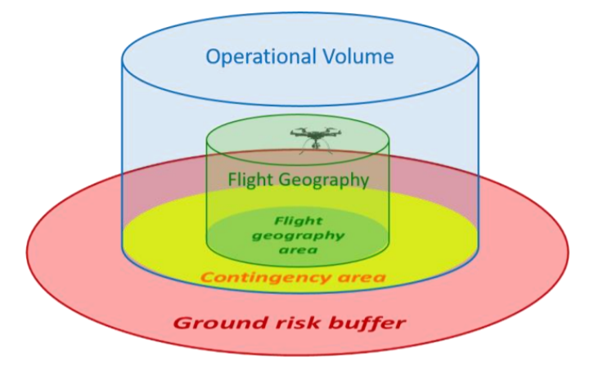
The contingency procedures are those applied under abnormal situations which would not compromise the controllability and stability of the UAS posing an imminent danger to those on the ground or in the air. The Operational Volume of your Operations allow for Contingencies to take place once the Drone Leaves the Flight Geography Area. This area gives the pilot extra time to either return the drone to the Flight Geography Area or land the Drone in the Contingency area of your Flight Operational Volume.
Image 29:Operational Volume

5.1.1 Sudden Change in Weather into adverse conditions Actions.
This situation occurs when the environmental conditions in the area of operations deteriorate into adverse operating conditions
Remote Pilot | Crew Actions (if present)
1. The Remote Pilot must identify the deterioration.  2. If the deterioration is reduced visibility and it looks visual contact with UAS might be lost, then UAS operations should stop immediately.  3. If the deterioration is multiplied wind speed on the far side UAS flight envelope or what's thought-about safe by RC for the present operations, then UAS operations should cease immediately.  4. If the deterioration may be a reduced air temperature to the purpose of attainable craft icing, then UAS operations should cease immediately. | 1. RTH Function can be activated.  2. Go to Force Landing Procedure

5.1.2 UAS Departs the Flight Geography Actions
This situation occurs when the UAS departs the Flight Geography and enters the Contingency Volume/Containment Volume.

The UAS may enter the designated Contingency volume as a result of some of the following examples:
- Evasive action: an unexpected obstacle or hazard has entered the flight path and the UAS must deviate to avoid it e.g., Birds or other aircraft.
- Interference: Interference to the UAS’ onboard sensors in either manual or automatic mode may cause the UAS to deviate from the expected flight path.
- Adverse weather: Weather conditions such as high winds could force the UAS outside the desired flight geography.

Remote Pilot | Crew Actions (if present)
1. Attempt to manually correct the UAS’ course.  2. If conditions worsen, go to Force Landing Procedure or activate the RTH Function.  3. If there is clear ground under the UAS and it is safe to do so, terminate the flight at least 10 m before the UA reaches the limits of the operational volume.  4. If none of the above work, please proceed to the “Fly Away Aircraft” procedure. | 1. Alert the Remote Pilot about the UAS incursion into the contingency volume.  2. Monitor the area under the UAS in case a Flight Termination Command is required

5.1.3 Sudden Mission Termination because of Compass Failure Actions.
This situation occurs when the internal compass in the aircraft has an error and not functional correctly. This can be caused by magnetic interference from the surrounding area e.g., deposits of metal, electric lines, etc.
- The function of the aircraft can be severely affected especially during automatic flight operations.
- The RTH failsafe may not work if interference is too strong.
- DJI Products with Compass Error or Failure will enter into Atti Mode this is where you maintain Height/Altitude but not position. Expect drifting when this happens, because of Wind. Drone will Drift at the same speed as the wind.

Remote Pilot | Crew Actions (if present)
1. Cancel any automatic flight operation and ensure the UAS is stopped in a manual mode.  2. Check the control functions of the UAS (forward/back, left/right, pitch /yaw).  3. Land as soon as practical.  4. Perform a compass calibration. | - Inform RP of weather changes.  - Inform RP of Wind Direction Changes.  - Monitor Weather Apps.

5.1.4 Telemetry Loss during Flight Mission Actions
This could be a situation where C2 Signal is weak or intermitting Remote Pilot will get a heads up warning on flight telemetry.
Points to Note:
- If your C2 Link signal is low, any operation that you command with the control app or RC might need to be attempted multiple times or could be delayed due to the weak C2 Link signal.
- If you transition from a low signal warning to loss of communication refer to the Lost C2 Link emergency procedures section of this document.

Remote Pilot | Crew Actions (If Present)
1. Where applicable cycle the mode switch from P mode to A mode and back to P mode. This is to take the Drone out of any Program mode. It gives Positive control back to the Remote Pilot.  2. Check that RC antennas are pointed up and out towards the UAS. Ensure no-one is standing directly in front of antennas.  3. Ensure distance from home reading in the app is within operational range.  4. Use the Return to Home button on the RC to land the UAS.(If need be try regaining positive control before activating RTH.)  5. Retrieve the UAS.  6. Establish probable cause of loss of signal to avoid a similar situation in future. | 1. Visually confirm if the UAS holds position.  2. Keep constant line of sight with the UAS.  3. Monitor for potential obstructions between the UAS and RC that could cause interference.  4. Visually confirm if the UAS has initiated Return to Home.

5.1.5 Interference Avoidance with Manned Aircraft Actions.
This situation occurs when there are visible or audible signs of an unknown third-party airspace user in the Adjacent Airspace with the intent of not changing course.

- This potentially could become a flight incursion.

Remote Pilot | Crew Actions (If Present)
1. RC should identify the probable course of the other airspace operator.  2. If it is likely that the other airspace operator could enter the operational volume, then start the “Unknown airspace user enters Operation Volume” procedure immediately. | 1. Assist RC in monitoring the unknown airspace operator.  2. Once threat passes by safely contact with ATC may be made to confirm their awareness of current UAS operations.

6. Emergency procedures
The UAS operator should define procedures to cope with emergency situations.

- Procedures to avoid or, at least minimise, harm to third parties in the air or on the ground. With regard to the air risk, an avoidance strategy to minimise the collision risk with another airspace user (in particular, an aircraft with people on board).
(b) Procedures for the emergency recovery of the UA (e.g., landing immediately, termination of the flight with FTS or a controlled crash/splash, etc.).

6.1 List of Possible Emergency’s
Below is a list of Emergency Procedures for various scenarios which will be adhered to by the Your Company Name UAS Operator. The procedures are as follows.
- Fail Safe
- Force Landing Procedure
- Software Malfunction
- Transmitter Failure/Frequency Interference
- Loss of Propulsion/Motor or Propeller Failure
- Aircraft Battery Failure
- Loss of GPS Signal
- Low Magnetic Field
- Public Encroachment
- Aircraft Incursion
- Fly Away
- Pilot Incapacitation
- Fire Ground Equipment
- Fire in Flight

Any emergency will be recorded in the Aircraft Hours Logbook under the “notes” section.

6.2 Fail Safe Procedure
If the remote-control signal is lost for more than 2 seconds, failsafe Return To Home automatically activates.
- Return to Home
- Once activated the aircraft starts to retrace its original flight route home.
- If the remote-control signal is re-established within 60 seconds the aircraft will hover at its present location for 10 seconds and wait for pilot commands.
- The UAS OPERATOR will press the RTH button on the remote controller to cancel RTH and take control.
- If no command is given the aircraft will fly in a straight line to the Home Point
- If the remote-control signal is still lost after 60 seconds the aircraft will stop retracing its original flight route and flies to Home Point in a straight line.

6.3 Force Landing Procedure
The following is the procedure to be followed when a forced landing is required.
Actions:
Remote Pilot | Actions
- Remote Pilot--------------------  - Remote Pilot--------------------  - Remote Pilot--------------------  - Remote Pilot--------------------  - Remote Pilot--------------------  - Remote Pilot--------------------  - Remote Pilot--------------------  - Remote Pilot--------------------  - Remote Pilot-------------------- | 1. Call “Force Landing Procedure” .  2. Check for Forced-landing site.  3. Heading for Forced-Landing Site  4. Check for obstacles  5. Check Telemetry a). Speed - controlled & Smooth, b). Flight Height – As Low & Safe as Possible  6. Check Satellites Still in ‘GPS Position’  7. Calculate consumptions & time left for flight.  8. Scan Landing Site.  9. Speed - Controlled & Smooth

NOTE
- If in Atti Mode watch flight height and confirm direction of the wind.
- The force landing

6.4 Software Malfunction
The following is the procedure to be followed when a software malfunction has been detected.
DETECTION
- The application fails to respond (Jammed).
- Software works slowly.
SIGNIFICANCE
- No control over UAS by application.
- No control over camera.
- No telemetry present.
IMMEDIATE ACTIONS
Remote Pilot | Actions
- Remote Pilot--------------------  - Remote Pilot--------------------  - Live Feed------------------------  - Flight Mode---------------------  - Remote Pilot--------------------  - Remote Pilot-------------------- | 1. Call “Software Crash” Reboot Device.  2. Check for Positive Rx from Drone Telemetry After reboot.  3. Check to see if Camera live feed is transmitting  4. Take Positive Control of UAS  5. Continue with Mission  6. Return to Home if Software Crashes a second time.
ACTIONS
Remote Pilot | Actions
- Remote Pilot--------------------  - Remote Pilot--------------------  - Remote Pilot--------------------  - Remote Pilot--------------------  - Remote Pilot-------------------- | 1. Radio connection.  2. Check for Positive Control from Drone.  3. Check to see if Camera live feed is transmitting  4. Check Positive Control of Camera  5. Check for free movement  6. Return to Home if Issue with Camera. Check Equipment after landing for damage
NOTE
In Case the Above-Mentioned Procedures Do Not Work.
- Fly by Visual.
- Return to Home Position.
- Altitude maintains until over Home Position.
- Speed - slow and steady until over Home Position.
- Power Consumptions – Are not present continuing flying is extremely dangerous, Land ASAP.

6.5 Transmitter Failure/Frequency Interference
The following is the procedure to be followed when a transmitter failure or frequency interference has been detected.
DETECTION
- The UAS fails to respond (Jammed).
- UAS starts RTH command without RP activating the RTH procedure
SIGNIFICANCE
- No control over UAS by application or by Sticks.
- UAS in RTH Mode
- Can’t take UAS out of RTH Mode
IMMEDIATE ACTIONS
Remote Pilot | Actions on if Communications is re-established
- Remote Pilot--------------------  - Remote Pilot--------------------  - Live Feed------------------------  - Flight Mode---------------------  - Remote Pilot--------------------  - Remote Pilot-------------------- | 1. Call “Fail Safe – No Control”  2. Check Antenna Positions  3. Check Position and Height of UAS  4. Take Positive Control of UAS  5. Continue with Mission  6. Return to Home if Interference happens a second time.

Remote Pilot | Actions on if Communications is not re-established
- Remote Pilot--------------------  - Remote Pilot--------------------  - Live Feed & Telemetry-------  - Flight Mode---------------------  - Remote Pilot--------------------  - Remote Pilot-------------------- | 1. Call “RTH – No Control”  2. Check Antenna Positions  3. Check Position and Height of UAS  4. Take Positive Control of UAS if possible  5. Land ASAP/Forced Landing Procedure ASAP  6. Continue in Return to Home Logic if safe to do so.
NOTE
- The flight team will then investigate the reasons why the failure occurred, log the incident, and report it to the UAS Accountable Manager

6.6 Loss of Propulsion/Motor or Propeller Failure
The following is the procedure to be followed when loss of propulsion or motor failure has been detected.
The UAS Operator will conduct the following actions.
DETECTION
- UAS Ground Station reports Motor Failure.
- UAS responses Sluggishly
- UAS Telemetry shows Motor Failure.
SIGNIFICANCE
- Manual control over UAS by Pilot.
- Monitor telemetry for further Information.
IMMEDIATE ACTIONS
Remote Pilot | Actions
- Remote Pilot--------------------  - Altitude---------------------------  - Live Feed------------------------  - Flight Mode---------------------  - Remote Pilot--------------------  - Remote Pilot-------------------- | 1. Call “Motor Failure”  2. Check Height of UAS  3. Check Position and Height of UAS if Changes Land ASAP/Forced Landing Procedure  4. GPS Mode  5. DO NOT Continue with Mission  6. Return to Home to go to Forced Landing Procedure.

ACTIONS
- UAS-----------------------------------Positive Control.
- Pilot-----------------------------------Positive Control/Check for free movement.
- Objective----------------------------Cancel and “Return to Home” or conduct Forced Landing Procedure.
NOTE
- The flight team will then investigate the reasons why the failure occurred, log the incident, and report it to the UAS Accountable Manager.

6.7 Aircraft Battery Failure
The following is the procedure to be followed when an aircraft battery failure has been detected.
The UAS Operator will conduct the following actions.
DETECTION
- UAS Telemetry show decrease and increase of Battery Voltage.
- UAS May decrease in Altitude and Hold Position.
- UAS Telemetry abnormal power surges in ESC’s.
SIGNIFICANCE
- Manual control over UAS by Pilot.
- Monitor telemetry for Battery Spiking.
IMMEDIATE ACTIONS
Remote Pilot | Actions
- Remote Pilot--------------------  - Altitude---------------------------  - Flight Mode---------------------  - Remote Pilot--------------------  - Remote Pilot--------------------  - Remote Pilot-------------------- | 1. Call “Battery Failure”  2. Check to maintain present altitude  3. Check for GPS Mode is selected  4. Take Positive Control of UAS  5. Drop Flight Height to Safe Height  6. Return to Home Position Manually

NOTE
- The flight team will then investigate the reasons why the failure occurred, log the incident, and report it to the UAS Accountable Manager.

6.8 Loss of GPS Signal
The following is the procedure to be followed when the GPS Signal has been lost.
The UAS Operator will conduct the following actions:
DETECTION
- UAS Drifts with Wind.
- UAS does not Hold Position.
- UAS Telemetry shows No GPS Connection.
SIGNIFICANCE
- Manual control over UAS by Pilot.
- Monitor telemetry for GPS reconnection.
IMMEDIATE ACTIONS
Remote Pilot | Actions
- Remote Pilot--------------------  - Altitude---------------------------  - Flight Mode---------------------  - Remote Pilot--------------------  - Remote Pilot--------------------  - Remote Pilot-------------------- | 1. Call “GPS” Failure  2. Check to maintain present altitude  3. Check to see if ATTI Mode is selected  4. Take Positive Control of UAS  5. Drop Flight Height to Safe Height  6. Return to Home Position Manually

ACTIONS
- GPS connection-------------------Confirm Connection Established.
- UAS-----------------------------------Positive Control.
- Pilot-----------------------------------Positive Control/Check for free movement.
- Objective-----------------------------STOP mission flight
- Pilot-----------------------------------Proceed with “Return to Home”

NOTE
- The flight team will then investigate the reasons why the failure occurred, log the incident, and advise the Accountable Manger.

6.9 Low Magnetic Field
The following is the procedure to be followed when a Magnetic Field has been detected.
The UAS Operator will conduct the following actions.
DETECTION
- UAS will move from its GPS Hold.
- UAS responses will be random, erratic & Fast.
- UAS Telemetry shows Magnetic Field.
SIGNIFICANCE
- Manual control over UAS by Pilot.
- Monitor telemetry for further Information.
IMMEDIATE ACTIONS
Remote Pilot | Actions
- Remote Pilot--------------------  - Altitude---------------------------  - Flight Mode---------------------  - Remote Pilot--------------------  - Remote Pilot--------------------  - Remote Pilot--------------------  - Remote Pilot-------------------- | 1. Call “Magnetic Field” Failure  2. Check to maintain present altitude  3. Check for GPS Mode is selected  4. Take Positive Control of UAS  5. Increase Flight Height to Safe Height to clear Magnetic Field.  6. Return to Home Position Manually  7. Re-Calibrate Compass Free from Magnetic/Metal objects

ACTIONS
- UAS-------------------------------- Test Flight to be conducted.

NOTE
- The flight team will then investigate the reasons why the failure occurred, log the incident.

6.10 Public Encroachment
The following is the procedure to be followed when there has been encroachment by the public.
The UAS Operator will conduct the following actions:
DETECTION
- People directly under UAS.
SIGNIFICANCE
- Manual control over UAS by Pilot.
- Monitor telemetry Information.
IMMEDIATE ACTIONS
Remote Pilot | Actions
- Remote Pilot--------------------  - Altitude---------------------------  - Flight Mode---------------------  - Remote Pilot--------------------  - Remote Pilot--------------------  - Remote Pilot-------------------- | 1. Call “public in Area of Operations” Failure  2. Check to maintain present altitude  3. Check to see if ATTI Mode is selected  4. Take Positive Control of UAS  5. Drop Flight Height to Safe Height  6. Return to Home Position Manually

ACTIONS
- UAS----------------------------------Observer to approach People stating the Dangers of the UAS in flight.
- Pilot----------------------------------Once the area is cleared, return to Mission.
- Observer----------------------------Monitor the Environment

NOTE
- The flight team will ensure prior to the continuation of the task the area is re-assessed and more preventative control measures are put in place.

6.11 Aircraft Incursion
The following is the procedure to be followed when there has been an aircraft incursion or suspected incursion. This will take place if another aircraft has been seen below 400ft (120m) within your operating area. The UAS Operator will conduct the following.
DETECTION
- Distance Sound of Manned Aircraft approaching.
- Manned Aircraft “Appears” in front of you.
- Manned aircraft identified
SIGNIFICANCE
- Manual control over UAS by Pilot.
- Avoid Manned Aircraft.
IMMEDIATE ACTIONS
Remote Pilot | Actions
- Remote Pilot--------------------  - Altitude---------------------------  - Flight Mode---------------------  - Remote Pilot--------------------  - Remote Pilot--------------------  - Remote Pilot-------------------- | 1. Call “Aircraft Seen North/South/East/West”  2. Drop present altitude to a lower safer Alt.  3. Check in GPS Mode if not, select it.  4. Take Positive Control of UAS  5. Drop Flight Height to Safe Height  6. Return to Home Position Manually

ACTIONS
- UAS--------------------------------------Positive Control.

NOTE
- Once a flight is complete both the UAS Operator and Observer are to fill out the ‘Incident Form’ and pass it onto the Accountable Manager.
- Accountable Manager will then investigate further and report to IAA.

6.12 Fly Away
The following is the procedure to be followed when the UAS is not adhering to the course plotted or as controlled by the UAS OPERATOR. The UAS Operator must conduct the following actions.
DETECTION
- UAS Continues on a course not controllable by the Pilot.
- UAS does not respond to any commands
- UAS Telemetry shows UAS continuing on heading.
SIGNIFICANCE
- Manual control over RPAS/UAS by Pilot.
- Monitor telemetry for further Information.
IMMEDIATE ACTIONS
Remote Pilot | Actions
- Remote Pilot--------------------  - Altitude---------------------------  - Flight Mode---------------------  - Flight Direction-----------------  - Battery Voltage-----------------  - Remote Pilot--------------------  - Remote Pilot-------------------- | 1. Call “Fly Away”  2. Present altitude record.  3. Check in GPS Mode if not select it.  4. Record Direction of flight.  5. Record Battery Voltage  6. Activate Return to Home function.  7. Visually monitor Drone flight direction
ACTIONS
Remote Pilot | Actions
- Remote Pilot/Crew------------  - Altitude---------------------------  - Flight Mode---------------------  - Flight Direction-----------------  - Battery Voltage-----------------  - Remote Pilot/crew-------------  - Remote Pilot/crew------------- | 1. Date Time Group (e.g 071030122021)  2. Present altitude record.  3. Estimated Battery Life/Flight time remaining  4. Record Direction of flight.  5. Record Battery Voltage  6. Contact ATC.  7. Assist the UAS Operator to find system

NOTE
- Both parties must complete the ‘Incident Form’ within 12hours of the failure and it must be submitted to the UAS Accountable Manager.
- If the system is found both parties must conduct the post-crash management procedure. If the system is not found the UAS Accountable Manager must be notified asap

6.13 Pilot Incapacitation
The following is the procedure if the UAS Operator at any time feels unwell or incapable of completing his task. He must conduct the following.
DETECTION
- UAS maintains heading.
- UAS Pilot States he is not feeling well.
- UAS Observer Gets Ready for a handover.
SIGNIFICANCE
- If Observer does not take over control of the UAS. It will fall out of the air after battery is depleted.
- Monitor telemetry for further Information.
IMMEDIATE ACTIONS
Remote Pilot | Actions
- Remote Pilot--------------------  - Remote Pilot -------------------  - Remote Pilot -------------------  - Crew/Remote Pilot------------  - Crew/Remote Pilot------------  - Remote Pilot-------------------- | 1. Must State that they are not feeling well, if time permits  2. If possible, Trigger Return to home function.  3. If Possible, Hand over to Crew Member.  4. Visual on Drone, Monitor RTH action.  5. Remote Pilot to Sit down close to Crew member.  6. after RTH completed Crew member to Administer First Aid if need be or call emergency services.

ACTIONS
UAS--------------------------------------------Positive Control

NOTE
- If medical attention is required, the Observer will call the local hospital and manage the area.
- If during the flight, there is a flight safety risk the Observer will take control of the system and land it.
- During the observer course this action will be tested. The UAS Accountable Manager is to be informed immediately.

6.14 Fire Ground Equipment
The following is the procedure will be implemented if there is a fire in any of the ground equipment. The UAS Operator will conduct the following actions.
DETECTION
- UAS Ground Station will have smoke or fire coming from it.
- UAS if losses Communications it will Return to Home.
- UAS Telemetry shows Return to Home Function activated.
SIGNIFICANCE
- Ground Station Unusable.
- Monitor telemetry for further Information.
IMMEDIATE ACTIONS
Remote Pilot | Actions
- Remote Pilot--------------------  - Ground Crew-------------------  - Ground Crew------------------- | 1. Call “Fire, Fire, Fire”  2. Ready Fire Fighting Equipment.  3. If Fire gets out of control Call Emergency Services.

ACTIONS
- UAS--------------------------------------Monitor while UAS is Landing.
The Observer will conduct the following actions.
- Observe the fire, ensuring it is not getting out of control
- Secure the area
- Manage any other parties in the area.

NOTE
- An incident form and equipment form must be filled out and sent to the UAS Accountable Manager as soon as possible.

6.15 Fire In Flight
The following is the procedure will be implemented if there is a fire in flight. The UAS Operator will conduct the following actions.
DETECTION
- UAS smoke or flames coming from aircraft.
- UAS does not respond to commands.
SIGNIFICANCE
- Manual control over RPAS/UAS by Pilot.
- Monitor telemetry for further Information.
IMMEDIATE ACTIONS
Remote Pilot | Actions
- Remote Pilot--------------------  - Flight Mode---------------------  - Ground Crew-------------------  - Ground Crew-------------------  - Ground Crew------------------- | 1. Call “Fire, Fire, Fire”  2. Check and Immediately Go to Forced landing Procedure.  3. GPS mode, Check - LAND ASAP.  4. Ready Fire Fighting Equipment  5. If Fire gets out of control Call Emergency Services.

ACTIONS
- Once the aircraft is on the ground the flight team will monitor the fire and start the incident form.
- The UAS Accountable Manager must be informed asap.
- If the fire starts to raise concern, then the emergency services are to be notified.

7. Emergency response plan (ERP)
This is a procedure which is applicable to most emergency situations
Remote Pilot
1. All flight operations at the operating area shall Stop.
2. Identify/Locate the incident site.
3. Establish communication to local ATC if required to inform them of the emergency and its status including all relevant telemetry, geographical and technical information as required. This is only if ATC need to be Notified as in if you are operating within Controlled Airspace or within the vicinity of Controlled Airspace.
4. Assess the situation prior to deciding if ATC need to be notified.
5. Contact relevant emergency services if necessary.
6. Secure the area surrounding the incident and ask/instruct any people unrelated to the operations to leave the area.
7. If staff are a first aid responder administer first aid to injured personal.
8. Ensure the public is kept clear of the incident site.
9. Identify any dangers or risks at the incident site and isolate and make safe if appropriate to do so.
10. Check on Injured parties. If further first aid is required apply.
11. Remote Pilot to keep communications with the affected stakeholders open. They include but are not limited to.
a. ATC
b. Police
c. Fire Brigade
d. Coast Guard
e. Ambulance
f. NAA
g. Landowners
Any other relevant site officials

7.1 UAS Loss of Containment Emergency Actions
In the event of an emergency, safety is the number one priority and preventing escalation.
Remote Pilot
1. Follow the “Fly away” procedure outlined in the Emergency Procedures.
2. Notify ATC and the relevant authorities/emergency services and follow all instructions given by them.
3. Liaise with other emergency services as necessary.
4. Inform Your Company Name Safety Manager and Accountable Manager of the Emergency. (They maybe the last person you notify, Emergency Services First.)

7.2 Immediately Post-Incident Actions
When the Emergency Response Plan is being triggered the following should be carried out once all danger to life or property has been negated.
Remote Pilot
1. Do Not Move anything. Slowly move into incident Site. Take a mental picture for later recall. If you have time quick sketch of area will help for reference later.
2. Record the incident in detail, record weather conditions as this will be vital for investigation later.
3. Document the situation with photos and videos. You can never take enough Photographs. One or two Photographs is not enough. You will need to cover the Incident area in detail with photographs. Then move to the aircraft crash site. Pay attention to damage to the UAS, damage to property/personnel, record locations and pieces of the UAS.
4. Gather contact information if the damages involve people or private property. If incident involves the likes of a pole, tree, ground, Wall, Building front, etc. Record and take photos of the site where the drone impacted. Even if no damage is visible. Record the Date & Time of when Photographs were taken and draw rough sketch.
5. Complete an incident / accident report. If possible, extract all necessary Logs and technical information from the UAS equipment.
6. Remove UAS from service if it is unsafe to fly and requires maintenance.
7. File all the necessary reports as per the Occurrence Reporting.

7.3 Environmental Emergency Actions
In the case of all environmental emergencies the following steps should be taken.
Remote Pilot
1. If possible, try to contain emission or spill immediately to avoid any further environmental harm. Remember Scene Safety and your Safety is First above anything else. If you do not have the correct PPE or equipment to deflect any Spill do not attempt.
2. If not trained to use shut-off vales don’t attempt to do so call site safety personal.
3. Raise the alarm locally to ensure further containment measures can be put in place or emergency response if required.
4. Your Company Name must report all significant incidents immediately to the local authorities and EPA to ensure regulatory compliance and initiate the appropriate response from those agencies.
5. Record with the use of Photographs and Sketch, record Wind direction and Speed.
6. Remember date time is also needed to be recorded write a brief outline of what happened. Bullet points are better in these circumstances than a detailed report.
7. Once back in office or at home a detailed report must be completed as the incident is still fresh in your memory. Do not put this report off until the next day.

7.4 UAS Loss of Containment Emergency Actions.
In the event of an emergency safety is the number one priority and preventing escalation.
Remote Pilot
1. Follow the “Fly Away” procedure outlined in the Emergency Procedures.
2. Notify ATC and the relevant authorities/emergency services and follow all instructions given by them.
3. Liaise with other emergency services as necessary.
4. Inform Your Company Name Safety Manager and Accountable Manager of the accident.
5. Once positive control is lost from the aircraft record its direction, speed, Battery voltage remaining, with DJI Products you will have actual approx. time remaining record this. Flight Height, Wind speed, Wind Direction, & Drone Speed.

8. Security
The relevant security aspects, including areas of application, safety measurements, procedures and responsibilities is described below:

8.1 Operational
In order to ensure that security requirements applicable to the area of operations are complied with in the intended operation, the following measures are taken:
- The take-off location is as secure as possible without infractions to public safety or population.
- The take-off location is monitored by the crew members, and in particular by the Remote Pilot.
- In case that the attendance of people at the take-off site or it is to difficult to manage by the Remote Pilot, the assistance of a VO shall be requested.
- All personnel involved in the operation, including visitors must wear a Your Company Name high visibility jacket.
- Remote Pilot must be easily identifiable.
In order to protect the operation against unlawful interference and unauthorised access, the following measurements are to be taken:
- Company Phones to have a secure lock to avoid Security Breach of data.
- Company laptops are protected with password to avoid Security Breach of data.
- Both the primary as well as the secondary telemetry links are protected with encryption from the Manufacturers. (DJI & Sensefly have encryption end to end technology during Flights.)
- Both the UAS and RP are under the constant watch of one of the crew members.
- The internet wireless Hotspot is protected with password.
- Company Wi-fi Dongle has a password to prevent to avoid Security Breach of data.
If the Remote Pilot is integrated inside a van, This is to isolate the crew from external distractions. This is not Normal Practice and should only be use if no other option is available. If there is a breach of Data, this must be reported to Your Company Name GDPR appointed compliance officer.

8.2 Data Protection
The UAS operator is responsible for complying with any applicable European Union and national rules, in particular, regarding privacy, data protection, liability, insurance, security and environmental protection. All operations will be designed to ensure that the UAS operations are in compliance with Regulation (EU) 2016/679 on the protection of natural persons regarding the processing of personal data and on the free movement of such data.

Personal data — Personal data is any information that relates to an individual who can be directly or indirectly identified. This includes
- Photograph
- Names
- Email addresses
- Location information
- Ethnicity, gender, biometric data, religious beliefs, web cookies, and political opinions.
Personal Data which is captured, and we have be given the permission to use this personal data, can only be used for which the permission was given. Once captured with permission still is personal data, permissions do not remove a persons rights to personal data or their right to privacy.

Personal Data has been captured by a UAS operation if the data displays any of the following:
- A person’s clearly visible face. However, if there are individuals in the distance and the faces are blurred, it is unlikely to be considered personal data.
- Any other personally identifiable attributes in another way – from the location, visible address numbers, car plate numbers, time of day, specific clothing, etc.
- It shows details about a person’s bodily characteristics, behaviour, private life or his or her professional activities.
- It is used when making decisions on how to treat, act towards or evaluate an individual person.
- It focuses on or targets a particular person, especially if for a prolonged period of time.

Data processing — Any action performed on data, whether automated or manual. examples include:
- Collecting
- Recording
- Organizing
- Structuring
- Storing
- Erasing

Data subject — The person whose data is processed. These include:
- Customers/Clients
- Site visitors

8.2.1 Definitions
Data controller — The person who decides why and how personal data will be processed. This will be carried out by a person nominated by Your Company Name.

Data processor — A third party that processes personal data on behalf of a data controller. For Data controllers a GDPR compliance checklist is available here https://gdpr.eu/checklist/

9. Guidelines to minimise nuisance and environmental impact referred to in UAS.SPEC.050(a)(v);
In order to minimise nuisances, including noise and other emissions-related nuisances, to people and animals, the RC and the crew shall:
- Wear corporate clothing to be easily identified and related with the operation by any external party.
- Sensitise communities about the nature and goals of the project, giving introductions to the UAS and operations and even exercising demonstration flights.
- Explain about the nature of the operations and UAS to any external party that may show interest or request information. The information shared must only be of general knowledge.
- If any external third party complains about the operation and wants to see the operations permissions, you are welcome to do so.
- Address to external parties in a calm and polite way. If the situation gets complicated call the police, retire and stay calm.
- Do not execute manual flights against or above unrelated people or publicum.

If any client, or manager sets you under pressure and you are uncomfortable with the operation do not face them directly. Refer them to the FOM instead and avoid direct conflict.

10. Occurrence reporting procedures according to Regulation (EU) No 376/2014.
Drones, are subject to accident investigations and occurrence reporting schemes. In the same manner as Manned Aircrafts. Voluntary or Mandatory reporting should be carried out using the reporting processes provided by the competent authorities (ECCAIRS). According to Regulation (EU) No 376/2014 as a minimum, this should contain:
Reporting procedures in case of:
- damage to property.
- a collision with another aircraft.
- a serious or fatal injury (third parties and own personnel).
The purpose of occurrence reporting is to improve the safety and reliability of aircraft and their operation and thereby to avoid accidents and serious incidents.

10.1 Reporting
In case of occurrence the RC must send a detailed occurrence report to the safety manager, the following documentation:
- Detailed description of the occurrence.
- Flight log (if the occurrence took place during flight).
- Telemetry log (if the occurrence took place during flight).
- Explanatory pictures.
  - Touch nothing
  - Do not move any parts or pieces
  - Take more than 20 images using your phone or Camera from different angles.
  - One or two Photos will not be enough.

The purpose of these internal reports is to identify safety related occurrences in operations and classify them accordingly for development of risk mitigation strategies and analysis.

10.1.2 Definitions
- Accidents, according to definition of 1.1.1 Definition of Terms
- Incidents, according to definition of 1.1.1 Definition of Terms

10.2 Starting a report.
Obligations to report apply in accordance with Regulation (EU) No 376/2014, see article 3(2). If the incident/accident/crash resulted in a fatal or serious injury to a person, or it involved manned aircraft then it is to be considered to be a serious incident/accident and must be reported. Any occurrence relating to the UAS operation that resulted in significant property damage and/or injury or the potential of injury to crewmembers, clients or members of the public should be reported.

Any occurrence resulting in a collision or near miss with another aircraft must be reported.
  - Weather
  - Mission planning
  - Pilot errors
  - Wrong procedures
  - Defect of UAS
  - Abnormal or erratic behaviour of the UAS
  - Hardware malfunctions, damages, or defects before starting operations
  - Software malfunctions or abnormal messages or behaviours

10.2.1 Requirements
Your Company Name has regular reporting requirements and accident incident-based reporting requirements. Incident and accident reports should flow from the Remote Pilot through the Safety Manager, but both have time limits on their submission. In the event it is not possible to coordinate with the Safety Manager, the Remote Pilot must submit them directly and follow-up with the Safety Manager as soon as possible.

10.3 Reporting Procedure.
Remote Pilot
1. Complete an incident/accident report (Appendix 3) onsite immediately post-accident/incident.
2. Notify the Safety Manager immediately with this information: a. Name of the RC.
b. Brief summary of the accident, including if any person or property was damaged.
3. In the case of an Accident or Incident: Within 12-hours send the completed Incident / Accident Report (Appendix 3) to the Safety Manager.
4. In case of Event of Interest: The Safety Manager will determine whether Accident Incident/Event of Interest Report Form needs to be completed and/or any other reports.
Safety Manager Actions
1. Submit an accident report with the IAA within 10 calendar days from the time of the accident using the European Aviation Reporting Portal (https://aviationreporting.eu/) If operating in another EU State this portal is to be used also, but RP must report to NAA of incident.
2. Accidents/serious Incidents involving the operation of a UAS must also be reported to the Air Accident Investigation Unit of the Department of Transport (info@aaiu.ie) and to the Flight Operations Department of the IAA in accordance with regulation or guidance material issued by the IAA (Mandatory Occurrence Reporting protocols).
3. Following an accident, incident or event of interest, the UA Operations Manager and relevant parties will debrief the RC and any crew members,
4. Confirm the following was in place at the time of the accident, incident or event of interest. a. RC held the appropriate certification.
b. Approval was granted by the UA Operations Manager for the mission location, date and time.
c. RC was complying with the conditions of the permissions UAS operations were under.
d. UAS that was involved was approved by the UA Operations Manager to be used.
5. UAS that was involved was operated in compliance with this OM, IAA regulations and with permission of local ATC (as applicable).
6. UAS that was involved was insured.

Your Company Name shall cooperate fully with the accident investigation body, competent authority, and other government entities (e.g., Gardai, Dept Of Transport, IAA) in relation to post accident investigations. All information, Personal Statements, Witness Statements pertaining to the accident/incident if requested will be shared with the relevant authorities in hard copy or soft copy. Any surviving flight logs or technical information from the UAS.

11. Record-keeping procedures
Description of instructions on logs and records of pilots and other data considered useful for the tracking and monitoring of the activity. The Following Logs are just suggestion only. If you have your own, you can insert a copy of them here. You must have at a minimum Pilot Logbook and Drone Flight Logbook.

11.1 Pilot Logbook
Pilot Logbook |  |  | Jan-2021 to Dec-2021
Date | UAV Type | Uav Ser Number | Location | Total Flight Time | Manual | Auto | Training- Test Flight | Client base Flight  Job No
0721 | PH4 | KL0871 | Dublin | 00:25 | YES | NO | Training
Table 12: Pilot Logbook
Summary: Last Page Hours Carried over __________________________
Total Flight Hours this page: ____________________________________

Signature___________________________________________________

11.2 Flight Logbook
Place Company Logo Here |  |  | Contact Details  Accountable Manager:  Chief Remote Pilot:  Remote Pilot:
Date | Payload | Operator  1 | Operator  2 | Site manager | Location | Launches | Time of Flight | Environment  Wind/Temp
Serial Number | Record of Defects |  | Serial Number | Maintenance Carried out |  |  | Worked  Done By | Date | Site Manager
Signature Block to be signed when all flight mission is filled.
Operator Signature:
Any Flight Issues:
Date:
Table 13:: Flight Logbook

11.3 Battery Logbook

Battery Logbook. |  |  |  |  |  |  | Page Number:
Date | Battery  Ser No. | Start  Charge Time | Start  Voltage | Finished  Voltage | End Charge Time | Total Charge Time | Signature | Remarks
Example | 100201 | 1630hrs | 25.3v | 29.5 | 0830hrs | 16 hours | Wayne Floyd | NTR

Table 14:Battery Logbook

11.4 Drone Maintenance Logbook

Maintenance Logbook |  |  |  |  | Page Number:
Date | Reason For Maintenance | Work Completed | Completed By | Parts Replaced | Test Flight Signature | Notes
Aircraft: (Serial No if required)
Model:
Firmware Version:
Software Version:
Date | Rotors | Motors | Controls Calibration | IMU calibration | Structural Check | Inspected by
Table 15: Maintenance Logbook

Last Page of Operations Manual
Insert Company Logo here

